English 10- Honours
The aim of English Language Arts 10 is to provide students with opportunities for personal and intellectual growth through speaking, listening, inquiry, reading, viewing, writing, and representing to make meaning of the world and to prepare them to participate effectively in all aspects of society.
The goals of English 10 Honours is to:
• comprehend and respond to oral and written language critically, creatively and articulately.
• communicate ideas, information, and feelings critically, creatively and articulately, using various media
• think critically and creatively, and reflect on and articulate their thinking and learning
- Question and explore the human condition through inquiry
- Possibly publish writing
- Extend thinking
• develop a continuously increasing understanding of self and others

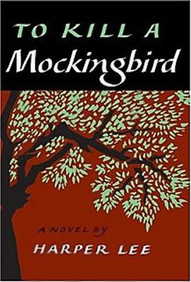
Content
Prose: Short Stories, To Kill A Mockingbird and an Independent Novel Study
Poetry: Traditional, Contemporary, Spoken Word
Drama: Othello or Much Ado About Nothing
Writing: Personal Reflections; Descriptive, Narrative, and Synthesis essays; independent creative writing project, Slam Poem
Inquiry: Exploring the human condition through literature and other sources
Grammar and Vocabulary: The mechanics of good writing and building sophisticated vocabulary on NoRedInk

Assessment
Assessment will be both Formative (homework checks, informal feedback, suggestions, and conferences, to help you learn) and Summative (to demonstrate what you have learned such as tests, projects, essays). Assessment will be based on skills, comprehension, creativity and participation.
Essays/projects/tests/assignments are worth 75% of the final mark.
Blog postings, reflections and essay corrections are worth 5% of your mark
NoRedInk grammar quizzes are worth 5% of your mark
There will be a final exam and personal reflection (based on concepts learned only in this class) at the end of the semester. This is worth 15% of your final mark.

Materials
Must have access to your edublog
Must bring everyday:
- Writing utensil (only blue or black pen or pencil)
- Electronic device with a charger with the following files:
  - English
    - Inquiry
    - Creative Writing
    - Essays and Writing
    - Short Stories
    - Of Mice and Men
    - Poetry
    - To Kill a Mockingbird
    - Grammar and Conventions
    - Shakespeare
- English texts/books you have been assigned

