The Butterfly / Pavel Friedman
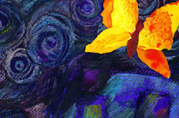
- The last, the very last,
- So richly, brightly, dazzlingly yellow.
- Perhaps if the sun's tears would sing
- against a white stone. . . .
- Such, such a yellow
- Is carried lightly 'way up high.
- It went away I'm sure because it wished to
- kiss the world good-bye.

- For seven weeks I've lived in here,
- Penned up inside this ghetto.
- But I have found what I love here.
- The dandelions call to me
- And the white chestnut branches in the court.
- Only I never saw another butterfly.
15. That butterfly was the last one.
16. Butterflies don't live in here,
17. in the ghetto.
Pavel Friedman: Friedman was a young poet, who lived in the Theresienstadt Ghetto. Little is know of the author, but he is presumed to have been 17 years old when he wrote “The Butterfly”. It was found amongst a hidden cache of children’s work recovered at the end of the Second World War. He was eventually deported to Auschwitz where he died on September 29, 1944.
- Mark up this poem. Look for poetic devices, imagery and meaning.

- What is the theme of the poem?

