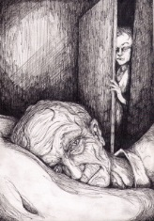
The Tell-Tale Heart- student worksheet
Prewriting: do ONE of the following questions
- Describe your favourite suspenseful (a quality in a work of fiction that arouses excited expectation or uncertainty about what may happen:a tale of mystery and suspense) story/movie/TV show. Why do you like it? What techniques are used to make it suspenseful?
- Describe a time when you felt really guilty. What did you do? Did you confess? Hold it in? How did you deal with it?

Questions to answer:
- Poe is a master at creating atmosphere. What are some of the story details and images that would have a strong appeal to a modern audience? How does it create suspense?

- What are the two symbols in this story and what do they symbolize? (when looking for symbols, look for something that is repeated many times and reinforces the theme)

- What are some of the conflicts in the story? What effect does telling the story from the narrator’s point of view have on the development of conflict?

Reading Response
- Would the story have worked if it had been written in the third- person? Rewrite the part with the police officers from a different point of view (omniscient, limited omniscient, objective).

