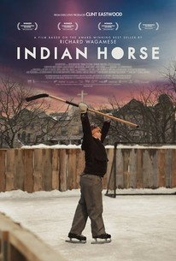
Introduction to “Indian Horse”
- Read chapter one together
- Each person in your group is assigned one question each. You are to write point form notes for your answers and use the material on my blog as your source.
Your answers will be on a group Office 365 Powerpoint. Each person has ONE -TWO slides each. Include images where you can.
- Research a brief history of Richard Wagamese. Include
  - Birth and death dates
  - Where he grew up and then lived as an adult
  - Childhood experiences that may have affected his writing
  - Cultural Background
  - His journey to becoming an author
  - Other facts that you think would influence his writing.

- The history of the Ojibwe people from 17th Century to the 19th Century. “Our ancestors learned to travel easily through territories that the Zhanagush, the white man, later feared and sought our help to navigate”.
  - What are the four main “branches” of Ojibwa people?
  - Economy- what was their relationship with the Europeans?
  - What was their primary diet?
  - How were they treated by the European settlers?
  - Explain why these people migrated.

- Spirituality of the Ojibwa people. “Our legends tell of how we emerged from the womb of our Mother the Earth; Aki is the name we have for her.” “Our people have rituals and ceremonies meant to bring us vision.”
  - How did the Ojibwe practice their spirituality?
  - What are some key terms they used for their beliefs and what did they mean? Eg. Manitou
  - Is there any common legends?

- Where did the Ojibwe people live? “We made our home in the territories along the Winnipeg River, where the river opens wide before crossing into Manitoba after it leaves Lake of the Woods and rugged spine of Northern Ontario.”
  - Include a map of this area. This can be a screen shot from google maps or an image found on the internet.
  - Find images of the landforms of this area. Look for images of the lakes, rivers, forest but be sure they are from this area. “…waving grasses that thatch the edges of our bays… granite ridges that rise above our homeland”

