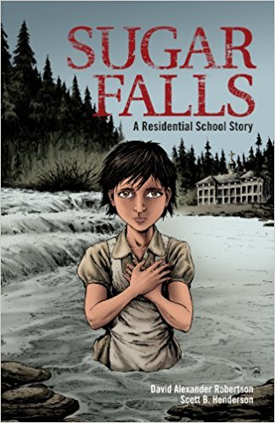
Sugar Falls: A Residential School Story
Pre-discussion:
What do you already know about residential schools?
Have you read any graphic stories in the past? Which ones? How is it different from reading a novel?
While you read:
Pay attention to your reading process. Look for details in the images that give clues to conflict and mood.
Inquiry Questions:
As the teacher in the introduction asks,
- How did residential schools affect the First Nation’s people of Canada?
- Why does it affect them still today?
- How does understanding the system change your view of First Nation’s people?
- Should it?
Questions to be answered below:
- What effect did the residential schools have on “kokum’s” mother?
Her mother experienced the residential schools and was mentally incapable of looking after her daughter. She also may be breaking the bonds with her daughter because she knows she may have to send her to the school and she cannot accept this possibility.

- What did Betsy learn at Sugar Falls when she visited with her father? What gives his people strength in dark times?
Betsy learns that it is the relationships (family, ancestors, nature, traditions) that help through the hard journeys

- Why did she have to go with the priest? (see page 16)

It is the law

- What are your immediate impressions of the priest and the nun? What does the illustrator do to give you this impression?
Aggressive, angry, dramatic, imposing. Makes the faces look like this. And the body posture.

- What was the point of the residential schools?
It was to eliminate their culture and “religion”, their traditions, and make them white and Christian. To assimilate them.

- A. Give three ways in which the nuns and priest try to achieve this goal.
- Not allowed to speak their language
- Forced to practice Christianity
- No contact with family and community
- Abuse them to show power
- Cut their hair
- Scrub their colour off (made them think they were dirty)
- Change their name

b. Which two had the biggest impact on the First Nation’s culture? Why?
- Taking away language (their culture is language based so that makes it even worse)
- By making children ashamed of their culture. How would this affect??? Secretive? Not being your true self. No individuality. Cannot talk or think of their past. Want to escape. Drinking and drugs and suicide.
- Sometimes The cycle of abuse is passed on to the next generation
- The legacy of residential schools

- a. The kids suffered horrific abuse. Which two do you think had the most impact on Betsy personally? Why?

- Physical abuse- no hearing in one ear
- Mental abuse- trauma
- Sexual-trauma/ loss of innocence
- Positive impact- more effort to be a better mom

- According to Betty, what does reconciliation look like? (page 40)

- Forgiving and staying true to your past and your culture
- To look at the past and look forward together with knowledge and healing
- To learn about the past

- Do you think a graphic story is an enjoyable way to read? What are the benefits? What are the challenges?

- The Canadian government and the Church tried to eliminate the culture and make them more “white”, yet Betsy survived because she held onto her First Nation roots and her relationships. Is this an example of dramatic, verbal or situational irony? How do you know?

- Situational irony- in an attempt to eliminate the culture, it only reinforced the ideas her father told her- hold on to the relationships of nature, tradition, family and ancestors

- What is a theme statement for this story? Think of the conflict, the plot, the characterization. Put together, what is the message for this story?

