Spoken Word Presentation
Presentation Dates :
The purpose of the Spoken Word Presentation is to honour the many different types of speaking that people are required to do in their daily lives. Your goal is to combine the expressive and dramatic reading of a poem and present it an interesting or entertaining way.
Speaking Styles
The Poetry Slam Finals will afford students three different styles in which to express themselves:
- Poetry Slam
- This I Believe
- Rant

- Poetry Slam –2 -3 minutes
Description: prepared performance poetry on thought- provoking idea using figurative language such as the following: pun, alliteration, personification, metaphor, simile, hyperbole, onomatopoeia, symbolism, imagery, and rhyme and sometimes synecdoche, allusion or irony. They often include recurring motifs or metaphors as per examples.
http://www.youtube.com/watch?v=VuAbGJBvIVY
Sarah Kay - Hands
http://www.youtube.com/watch?v=JfTa4B7wQ_8&feature=related
Eric Darby “Scratch and Dent Dreams”

- This I Believe – 2-3 minutes

Description: a prepared impassioned commentary on a topic important to the speaker. It may be silly, serious, humorous, satirical or ironic. Written more like an essay.
Below is a list from the top 25 This I Believe “Essays” as they were read on the radio. Below is a selection but you may choose your own or have students choose a variety.

http://thisibelieve.org/index.php
Home page for “This I Believe”

- Rick Mercer Style Rant- 2-3 mins
Editorial or commentary delivered in a convincing fashion. It is not a calm argument but one that is enthusiastically presented. It focused on an idea, a person or an institution. Can be based on fact but there is room for comedy and satire.
Rick Mercer Rant- http://www.youtube.com/watch?v=CKtqHm_ygu0

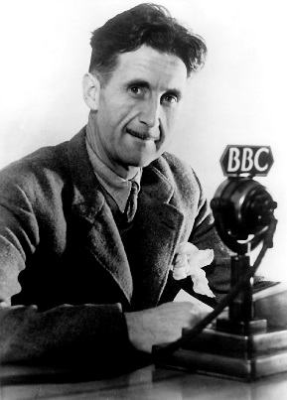
Tips for writing according to George Orwell:
George Orwell has earned the right to be called one of the finer writers in the English language through such novels as 1984, Animal Farm, and Down and Out in Paris and London, and essays like "Shooting an Elephant."
A scrupulous writer, in every sentence that he writes, will ask himself at least four questions, thus:
- What am I trying to say?
- What words will express it?
- What image or idiom will make it clearer?
- Is this image fresh enough to have an effect?
And he will probably ask himself two more:
- Could I put it more shortly?
- Have I said anything that is avoidably ugly?
One can often be in doubt about the effect of a word or a phrase, and one needs rules that one can rely on when instinct fails. I think the following rules will cover most cases:
- Never use a metaphor, simile, or other figure of speech which you are used to seeing in print.
- Never use a long word where a short one will do.
- If it is possible to cut a word out, always cut it out.
- Never use the passive where you can use the active. (“I write poetry” is better than “ I am writing poetry”)
- Never use a foreign phrase, a scientific word, or a jargon word if you can think of an everyday English equivalent.
- Break any of these rules sooner than say anything outright barbarous.
Other tips:
- Use strong verbs and nouns, not just great adjectives. Eg. “strut” instead of “walked”
- Don’t rely on a thesaurus’ as the meaning doesn’t always match.
- Just write and then fix it later.
Possible Topics:
- “A love story to my…..”
- Body parts and their significance
- Emotions and their imagery
- Abstract nouns- can you describe them using sensory words?
- Social issues- personify them? Extend the metaphor? Sensory words?
- Personal issues. Attack them!

