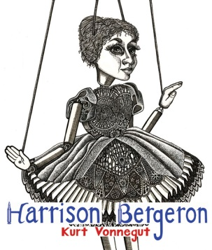
Harrison Bergeron
A dystopia is defined as a seemingly utopian society with at least one fatal flaw; in Vonnegut’s "Harrison Bergeron", the setting is "a ruthlessly egalitarian society, in which ability and accomplishment, or even competence, are suppressed or stigmatized as forms of inequality”. This story was published in 1961, when the USA was still engaged in a Cold War with Communist Russia. This story satirizes the idea of a perfect, equal society that many societies strive to achieve.
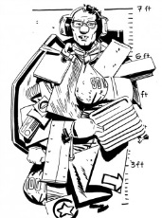
Literary Concepts: satire, dystopia/utopia, symbolism, irony, theme
Vocabulary:
- required: dystopia, utopia, egalitarian, satire
- Logophile: four words from the story
Prewriting:
- Prewriting-
  - Concept of Definition Map of the term “utopia”.
  - Write a short paragraph outlining what you think would be a utopian society
- Discussion web- Are people equal? Discuss as a group and record your answers.
- Read and analyze the following poems: “Imagine”, “Blowing in the Wind” and “The Sound of Silence”.
- Discuss the meaning of the Calvin and Hobbes comic below
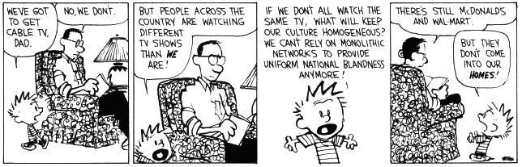
Reading Strategies: questioning, visualizing, inferring
During reading:
Use the questioning/inferring sheet as you read. We will do the first few together.

To Discuss In Your Groups:
- Discuss the role of TV in this story. What is Vonnegut trying to say about the use of TV in our society?
- Track the different sounds that George hears. In a chart, describe each sound in order and discuss its significance. They are NOT random sounds.
- Do you think that the death of Harrison was staged by the H-G?
- If Harrison was able to declare himself emperor, how do you think he would have changed society? Would it be better, worse or the same?
- What “handicaps” are imposed on people today? Are all talented people able to explore and show their talent? Discuss.
- “He should get a nice raise for trying so hard.” Should people be paid based on effort or ability?
- The characters in the story are meant to symbolize “types” of people in American society. Describe who the Handicap General, Harrison, George and Hazel all signify.
To Record In Writing:
- Discuss the role of TV in this story. What is Vonnegut trying to say about the use of TV in our society?
- The characters in the story are meant to symbolize “types” of people in American society. Describe who the Handicap General, Harrison, George and Hazel all symbolize.
- Using examples from the story, explain how “Harrison Bergeron” is a satire.
- What is a possible theme of this story? Put it into a theme statement.
- Can you propose 1-2 inquiry questions for this story?
Reading Response: Choose ONE to answer in a detailed, insightful response
- We live in a world of discrimination based on inequality, intolerance and ignorance. Do you think we can ever stop discrimination based on inequality? What is stopping us? How can we stop it? OR
- “He should get a nice raise for trying so hard.” Should people be paid based on effort or ability?
Inquiry Response: fill in the “Building Understanding” sheet. File in your “inquiry” file folder on your computer.

