English 11
The aim of English Language Arts 11 is to provide students with opportunities for personal and intellectual growth through speaking, listening, reading, viewing, writing, and representing to make meaning of the world and to prepare them to participate effectively in all aspects of society.
The goals of English 11 is to:
• comprehend and respond to oral and written language critically, creatively and articulately.
• communicate ideas, information, and feelings critically, creatively and articulately, using various media
• think critically and creatively, and reflect on and articulate their thinking and learning
• develop a continuously increasing understanding of self and others

We will focus on the essential questions:
- How do you define yourself? How can you express who you are through your writing?
- What skills can we use to understand how the authors of literature, poetry, song and articles express identity?
- What can we learn about ourselves and the world by exploring other identities?
- What characteristics and actions make an effective leader?

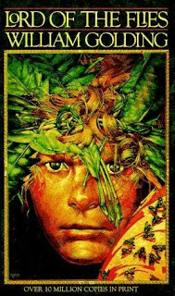
Content
Prose: Short Stories, Novel- Lord of the Flies
Poetry: Traditional, Contemporary, Spoken Word
Drama: Macbeth
Writing: Personal reflections and opinion pieces; four types of essays such as persuasive, descriptive, narrative, and a compare and contrast.
Grammar and Vocabulary: The mechanics of good writing and building sophisticated vocabulary using mentor texts, logophiles and the online site, Grammar Bytes.

Assessment
Assessment will be both Formative (informal feedback, suggestions, and conferences to help you learn) and Summative (to demonstrate what you have learned such as tests, projects, essays). Assessment will be based on skills, comprehension, and creativity.

Materials
Must bring everyday:
- Writing utensil (only blue or black pen or pencil) and highlighter
- English duotang/ binder with paper. You can leave this in the classroom if you do not have homework.
- English texts/books you have been assigned
