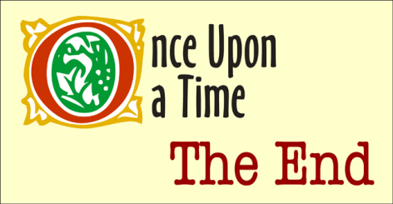
Introduction to Short Stories
Understanding how a story is put together is another way in which you may enhance your appreciation of what an author is portraying in a story. To do this, you must know the characteristics and the elements of a short story.
- General characteristics
  - The length may vary from 1000 words- 30 000 words but it can be read in one sitting
  - It has an overall sense of unity and finality. Nothing is included that does not farther the action. Therefore, nothing can be added or taken away
  - It deals with one situation and has no subplots, therefore conveying a single message
  - There is a distinct climax or crisis, which develops directly from the conflict
  - It has one central character and very few others, with no unnecessary characterization
- Types of Short Stories
  - Plot- characters are less important than the events
  - Character- incidents are chosen to develop a character
  - Atmosphere- actions and persons are used to realize and express a certain atmosphere

- Escape vs Interpretive Literature
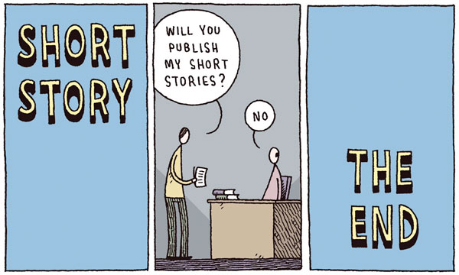
A short story or any piece of fiction, which seeks to merely entertain the reader, is ESCAPE fiction. It helps the reader pass the time agreeably, takes them away from the real world and enables them to temporarily forget their troubles. On the other end of the scale is INTERPRETIVE literature. It is written to broaden, deepen and sharpen the reader’s awareness of life; it takes the reader deeper into the real world, and enables them to understand humankind’s troubles. We need reading strategies the most for this kind of fiction.

Plot Profiles
Plot is the framework of the story; it is the sequence of events or incidents of which the story is composed. Plot consists of an introduction, rising action, conflict, climax, denouement and conclusion. Note: not every short story has a denouement or conclusion!

- Introduction
  - Sets the mood
  - Gives the setting
  - Introduces any necessary background info
  - Introduces the main characters
  - Arouses interest
- Rising Action
  - It is the major portion of the plot made up by various complications (plot these complications)
- Climax
  - It is the highest point or turning point of the story
  - Indicates what is going to happen next
  - Is the highest point of interest and emotion
- Denouement
  - The unravelling of thoughts
  - Explains what really happened; shows the effect of the climax
- Conclusion
  - Explains the details that require any farther clarification
  - Wraps up the story

