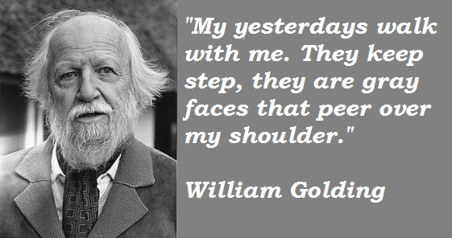
Author Biography and Context
Whilst it is not necessarily imperative to know about an author’s background when responding to a text, background information helps us to frame the context in which the text is written. After all, no text is written in a vacuum; a writer like Golding, creates something which reflects his experience and his view of life. Novels are only sometimes autobiographical, but rarely do they not develop out of the writer’s actual or imaginative experience. In the case of Lord of the Flies, Golding’s nationality, class, age, occupation and experience are all relevant to the way in which the book developed our understanding of the text. Golding fought in WW II and participated in D-Day in Normandy. This experience, and many others, coloured his view of the world.
Like many people after WW II, Golding was devastated by the genocide committed by the Germans and the Japanese. They found it difficult to believe that civilized people could be capable of the atrocities perpetrated against the Jews and others by the Nazis. Well educated people like Golding had tended to believe that mankind was not inherently evil, rather evil behaviour was the result of ignorance and superstition. The behaviour of Nazi Germany caused Golding to rethink his ideas and in Lord of the Flies he attempts to explore and understand why people who are supposedly civilized can embrace evil.
During the Nineteenth Century and the early part of the Twentieth, people in Britain, Europe and America tended to believe that they had developed the ultimate values of law, democracy, organization and religion, and had created a social order which enabled the basic good in human beings to flourish. They believed that the French philosopher Jean Jacques Rousseau was correct when he said that: Man is born free, but everywhere is in chains. They interpreted Rousseau’s views to mean that man is born good and that it is his experience of society that corrupts him. Now that they had sorted out the evils of society, all humans could live in harmony. WW I disturbed this view somewhat, but they argued that it was an aberration and that people would learn from that experience and never go to war again.
As has been suggested, the holocaust shattered this certainty. Golding, who was a prep school teacher, observed his students and came to believe that far from being naturally good, humankind was basically evil and that it was only the rule of law and civilization and the threat of punishment that kept people from behaving evilly.
In order to explore his views in his novel, he took a popular children’s novel by R.M. Ballantyne, entitled Coral Island, and parodied its central plot and theme. In Coral Island, two British schoolboys, Ralph, Jack and an Australian boy, Peterkin, are marooned on a desert island. They encounter adventures with cannibals, pirates, wild animals etc. and came through the adventure bravely and successfully because they are British.
Whilst Golding uses a similar idea and even uses the same names for the two main characters, his vision of how British schoolboys would behave in these circumstances is very different to that of Ballentyne.
Lord of the Flies can be seen as an allegory; that is a piece of writing in which the apparent meaning of the characters and events is used to symbolise a deeper meaning- moral, spiritual, political or social. Consequently, it is possible to see the characters of this novel as being symbolic of different attitudes and/or personality traits.
Questions:
- What global events shaped Golding’s view of the world?

- What personal events shaped Golding’s view of the world?

- What did the powerful Western countries believe about themselves at the turn of the century?

- What was Jean Jacque Rousseau’s philosophy?

- What did Golding believe kept people from behaving poorly?

- What novel did Golding parody? What did Golding take from this novel to adapt to his?

