Inferring in Poetry
Writers do not give everything away in poetry- it is meant to be discovered and explored! The reader must INFER meaning because poetry is usually much shorter than a story.
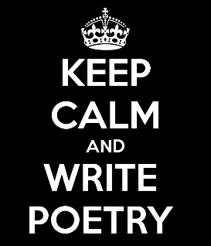
Personification- giving inanimate objects human characteristics.
- Feelings
- Actions
- Voice
You will write a poem using the technique of personification BUT you want your reader to INFER your topic.
Brainstorm- what qualities would a hockey puck have?
- Description- black…..
- Action- glide…..
- Feelings- excited….
- Voice- “Stop slapping me!”…
Choose an object that you will add human qualities to (could be a man-made object OR an object in nature) OR choose a situation to personify (bullying, smoking, drugs, gangs, poverty, cheating, shoplifting, animal abuse, global warming) :
________________________________________________________________________
- Description-
- Action-
- Feelings-
- Voice-
When you write your poem, one of your goals is to have your reader infer what your poem is about. Because of this, you are NOT to give your poem a title. Also, you have to try to write in such a way as to not five too much information away too quickly. You don’t want your reader to figure out the topic immediately, but rather you want to leave room for them to try to infer or figure it out for themselves. See the poem below as an example:
Title ____________________________________________
Never-ending torture.
I weigh you down,
Your backpack, your brain,
Your calendar.
I haunt you
and hover just below
the edge of your happiness.
I interfere with your friendships,
Your screen time, your fun.
Just when you think
you are finally rid of me,
I return in a rush of stress,
To fill your mind and your desk.
I hold you hostage all year
And you will only be free of me
At the end of June.
Notes in writing:
- First person!
- Play around with ideas and different phrases when writing
- Poem contain short phrases- note the punctuation above.

Final product:
Fold a paper in half- on one side, write the poem- on the back side- put the title and a short illustration. The idea is that people will read the poem and then have to see the title on the back to see if they inferred correctly.

