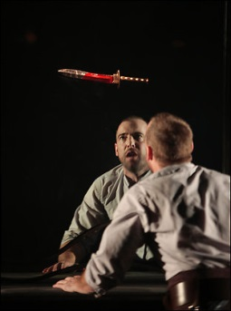
Macbeth- Scene 2.1-2 “Is that a dagger which I see before me?”
Setting the Stage: In earlier times, the duties of the host were very important. Only major cities had inns for travellers. Therefore, travellers were meant to stay at a stranger’s house. The host was expected to provide a guest with food, shelter, and protection. Harming a guest was a terrible crime.
A visitor also had strict rules of behaviour such as honouring the host with gifts. The King repays the Macbeth’s for their hospitality in contrast to their plans for him.

The scene opens outside the castle with Banquo and Fleance discussing the strange, dark night. Macbeth is haunted by what he is about to do.

- Banquo is exhausted but cannot go to sleep. What keeps him from sleeping?

- When Banquo mentions the three Witches, what is Macbeth’s reply?

- When Macbeth is alone, he sees a “fearful vision”. Describe what he sees.

- What are the “allusions” that Shakespeare refers to in line 52 and 55.

- How does Macbeth describe the night?

Famous Quotes- in your own words, explain what this quote means (paraphrase)
Macbeth- “Is this a dagger which I see before me?” (line 33) (also explain the significance of this quote to the story) ______________________________________________________________________________________________________________________________________________________________________________________________________________________________________________________________________________

Scene ii- The plot to murder Duncan would have been a familiar threat to King James. He knew how dangerous it was to be a monarch. His mother- Mary Queen of Scots (Bloody Mary)- was executed for plotting against Queen Elizabeth. And his father was mysteriously murdered as well. James’ aunt, Anne Boleyn, was beheaded by her own husband (King Henry VIII).
Lady Macbeth is frantically waiting for Macbeth to return from Duncan’s bedroom. She hears the owl scream and the crickets cry. Symbolically, these are bad omens. He soon enters and reports the outcome of their plan.
- Why doesn’t Lady Macbeth kill Duncan when she has the chance? ________________________________________________________________________________________________________________________________________________________________________
- Lady Macbeth warns Macbeth that they must not think so seriously about the deeds or they will _______________________________.
- Macbeth reports that he thought he heard a voice cry, “Sleep no more. The Thane of Glamis has murdered sleep.” Read the lines following this quote. Why do you think Macbeth may not be able to sleep? ____________________________________________________________________________________________________________________________________________________________________________________________________________________________________________________________
- Why does Lady Macbeth return to Duncan’s room? ___________________________________________________________________________________
Quotes- put in your own words and explain the meaning
Macbeth “Will all great Neptune’s ocean wash this blood clean from my hand?” (line 60) ____________________________________________________________________________________________________________________________________________________________________________________
Macbeth- “A little water clears us of this deed: how easy it is then.” (lines 68) ____________________________________________________________________________________________________________________________________________________________________________________
Question to discuss:
Who is responsible for Duncan’s murder? What part do Macbeth, Lady Macbeth, the witches, fate, and even Duncan himself play? Who is primarily to blame? Back up your opinion with quotes.

