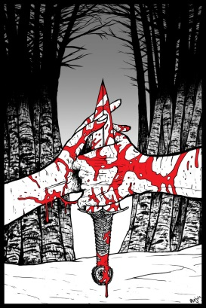
Macbeth
Act 1, Scene 1
The play opens at night during a furious thunderstorm. As the lightning flashes, three witches appear in a deserted field. The “wyrd” creatures speak to one another in mysterious phrases.
- The witches plan to meet again when _______________________________________________________________.
- The three witches will see _________________________ the next time they meet.
- All three witches agree that things are really not what they seem to be. They say “The beautiful is ugly and the ugly is beautiful”. What do the witches say to mean this: ________________________________________________________________________________________________________________________________________________
- Think about the meaning of the quote in question 3. Based on this quote, what kind of world would you say Macbeth lives in?

Scene 2
The scene opens as a war is in progress. Scottish rebels and Norwegians are attacking forces loyal to the Scottish king. Now the Scottish king (____________) , his soldiers, and his two sons (______________________ and __________________) await news of the latest battle. They watch as a wounded captain approaches their camp.
- What news does Captain bring about the battle between Macdonwald and Macbeth? ________________________________________________________________________________________________________________________________________________

- According to the captain, what did Macbeth and Banquo do when the Norwegian troops began a new attack? ________________________________________________________________________________________________________________________________________________

- What is a thane? _______________________________________________________

- When the king hears the battle report, he gives Ross two important commands. What does he order Ross to do? ________________________________________________________________________________________________________________________________________________
- You have not yet met Macbeth but you have heard about him. Predict what kind of man you think he will be. Give two quotes to back up your answers. ________________________________________________________________________________________________________________________________________________________________________________________________________________________________________________________________________________________________________________________________________________________________________

