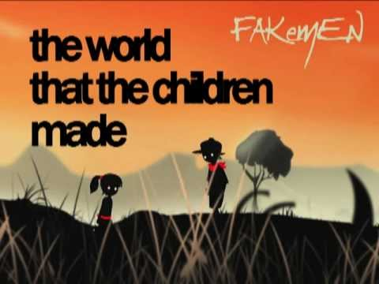
“The Veldt” by Ray Bradbury
Essential Question: When does technological progress negatively affect human relationships?
Concept Focus: irony, foreshadowing, conflict
Reading Strategies: questioning, inferring (and visualization)
Prewriting: Does technology improve your life? When is it beneficial and when is it harmful? Refer to an experience in your life if you can.

During Reading: While reading, record the deep questions you may have. Then, answer with a “maybe”. You are inferring the answer to your question based on evidence from the story.
For Discussion:
- The happened to the parents? Explain your reasoning.
- How has advancements in technology affected the kids? The parents? The family as a whole?
- Why do you think this story was originally called “The World the Children Made?”
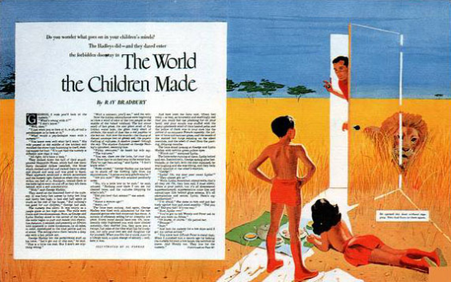
- Where is the irony in this story? Do you know what kind of irony it is?
Questions to answer in writing:
- What explanation can you give for the father’s wallet and the mother’s scarf being in the nursery? What does this suggest about the events to follow?
- How does the author create and maintain suspense?
- Where is the irony in this story? What kind of irony is it?
- How has advancements in technology affected:
  - The kids?
  - The parents?
  - The family as a whole?
Response Writing: Either answer the essential question OR respond to the story how you choose. Can you connect to the story? Do you like the story? Why? What do you think of the author and his view on life?
Literary Terms- Refer to your terminology booklet for answers
- Fill in your literary terms graphic organizer.

