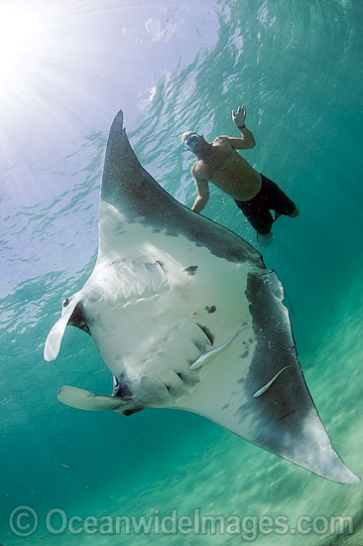
“The Sea Devil” by Arthur Gordon
Essential Question: Are humans the superior species?
Concept Focus: conflict, irony, mood, symbolism
Reading Strategies: visualizing
Prewriting: Relate a memorable brush with danger or death you or someone you know once had.

During Reading: While reading, visualize the scene. Make a movie in your head as you read. What is the mood that the author is trying to portray? What words/phrases are used to portray this mood?
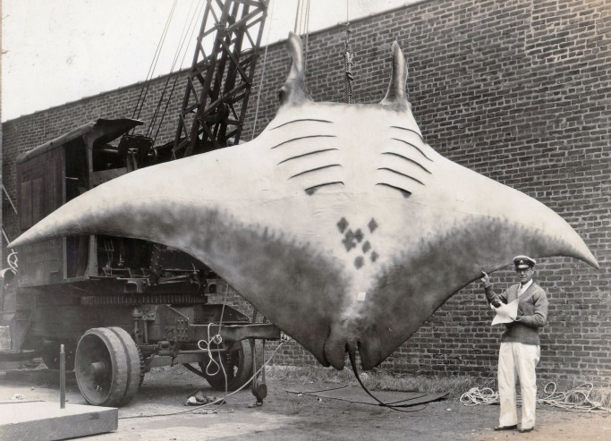
Post Reading: Sketch 2-4 scenes that you visualized in your head. Make either a storyboard or just a few images randomly placed on the page. THIS IS NOT ART- STICK FIGURES ARE ALLOWED. YOU DO NOT HAVE TO COLOUR.
For Discussion:
- How did “the man” save himself?
- What does this story tell us about human dominance over nature?
- Why do you think the author only calls him “the man”?
- Where is the irony in this story? Do you know what kind of irony it is?
Questions to answer in writing:
- Why does the man fish at night? How does this lead to the conflict with the ray?
- What has the man learned at the end of the story? Why does he release the mullet?
- One of the conflicts in the story is between the civilized and the primitive. What is the purpose of the reference to the plane, the causeway, the books lined up orderly on the shelf?
Response Writing: What does this story tell us about human’s mastery over nature? Who is the most dominant? Be sure to reference the story.
Literary Terms- Refer to your terminology booklet for answers
- Fill in your literary terms graphic organizer.

