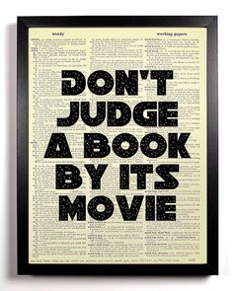
Response Writing to Fiction
Responding to fiction is designed to have you thinking about and relating to what you read. The point is for you to show that you have interacted with the text (various quotes, ideas, themes, visuals, etc) in a thoughtful, deep and meaningful way. The text made you think and you are showing me how and about what. This where you get ideas and learn to read more deeply into what is presented to you.
Here are some ideas for your response. It can refer to 2 or more of your reading strategies such as:
- Asking deep questions and inferring the answer
- Connect to events in your life
- Connecting to the real world, society, real events, human nature
- Connect to other literature that you have read or movies you have seen
- The imagery or visualizations you saw as you read
- Transform your thinking- did you change your mind about an issue after read the story/article?
Or your response can:
- Critique-the author’s style, diction, symbolism, characterization, setting, irony and satire.
- Give and support your opinion about whether or not the article is good
- Pick out and discuss the main ideas, themes, or issues

