Objective: to write a 150-300 word descriptive paragraph.
Steps to write a descriptive paragraph
- Copy this table onto a document. Have about 5 line spaces per row.
See
Hear
Taste
Touch
Smell
Look at the image below. Fill in your table with descriptive words- be sure they are specific and strong.
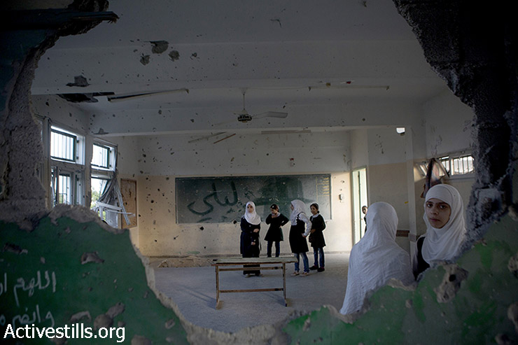
- What is the purpose of your paragraph? Is this a description of a person? A place? An experience? An event? (some examples- “ A broken region”, “hope”, “anger”, “organized destruction”, “mourning”. )
My Purpose: __________________________________________________________________________________________________________________________________________________________________________
- Now write a first draft of your paragraph keeping your purpose in mind. Don’t worry about spelling, grammar, etc. Just write! (Assignment is 150-300 words.)
- Revise, revise, revise. Do you have:
  - A topic sentence?
  - Is your purpose obvious?
  - Do you have a strong conclusion?
  - Do you use strong, specific words instead of vague words?
Can you:
- Play with your sentences? (change it up! Eg. The cat loves to sit in the sun and purr. OR Sitting in the sun, the cat stretched, then purred contently.
- Improve your vocabulary with stronger words?
- Insert some humour? A poetic device like a simile or metaphor? An attitude?
- Formatting- name, title and date on the top of the document. Underline the title.

Due Thursday, September 2nd. Please put in the hand-in box on my Sharepoint site OR print out your paragraph and give to me personally.

