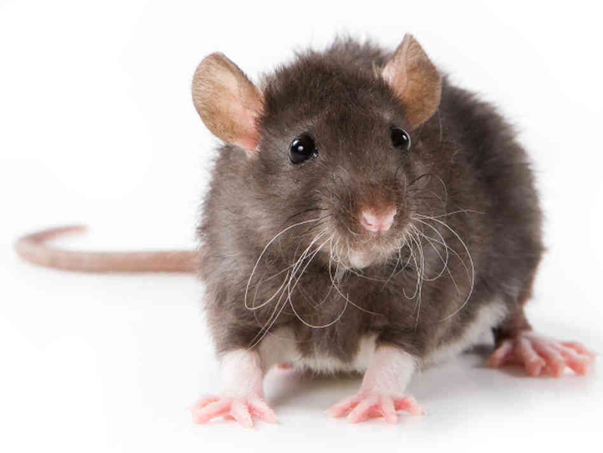
“Barney” by Will Stanton
Essential Question: When does experimentation for the sake of scientific progress go too far?
Concept Focus: irony, foreshadowing
Reading Strategies: questioning and inferring
Prewriting: Should animals be used in experiments to progress science? Explain your reasoning.

During Reading: While reading, record the deep questions you may have. Then, answer with a “maybe”. You are inferring the answer to your question based on evidence from the story.
For Discussion:
- What happened to Tayloe? Explain your reasoning.
- Why does the spelling get so bad by the end of the journal?
- Where is the irony in this story? Do you know what kind of irony it is?
Questions to answer in writing:
- On what grounds is Tayloe fired? How does the protagonist rationalize Tayloe’s dismissal? What is the real cause for his dismissal?
- Find and explain three examples of irony in the last two paragraphs of the story.
Response Writing: Scientific research is taking us in different and new directions everyday. What is your opinion on limitations placed on researchers and scientists? Should people be allowed to carry out research in private? Why or why not? Where should the line be drawn on projects such as genetic mutation, gene research, animal testing, human testing and other controversial research? Be sure to defend your position with real-life examples OR examples from the story.
Literary Terms- Refer to your terminology booklet for answers
- Fill in your literary terms graphic organizer.

