English 11
The aim of English Language Arts 11 is to provide students with opportunities for personal and intellectual growth through speaking, listening, reading, viewing, writing, and representing to make meaning of the world and to prepare them to participate effectively in all aspects of society.
The goals of English 11 is to:
• comprehend and respond to oral and written language critically, creatively and articulately.
• communicate ideas, information, and feelings critically, creatively and articulately, using various media
• think critically and creatively, and reflect on and articulate their thinking and learning
• develop a continuously increasing understanding of self and others

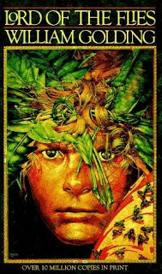
Content
Prose: Short Stories, Novel- Lord of the Flies
Poetry: Traditional, Contemporary, Spoken Word
Drama: Macbeth
Inquiry: exploring the human experience
Writing: Personal reflections and opinion pieces; formal paragraphs in response to literature, informal responses to literature, 2-3 types of essays such as persuasive, descriptive, narrative, and/or a compare and contrast.
Grammar and Vocabulary: The mechanics of good writing and building sophisticated vocabulary using mentor texts, logophiles and the online sites, Grammar Bytes, and No Red Ink.

Assessment
Assessment will be both Formative (homework, informal feedback, suggestions, and conferences to help you learn) and Summative (to demonstrate what you have learned such as tests, projects, essays). Assessment will be based on skills, comprehension, depth and insight, and creativity.

Essays/projects/tests/assignments are worth 75% of the final mark.
Blog postings, reflections and essay corrections are worth 5% of your mark
NoRedInk grammar quizzes are worth 5% of your mark
There will be a final exam and personal reflection (based on concepts learned only in this class) at the end of the semester. This is worth 15% of your final mark.

Materials
Must bring everyday:
- Writing utensil (only blue or black pen or pencil) and highlighter
- Electronic device with a charger with the following files:
  - English
    - Inquiry
    - Lord of the Flies
    - Essays and Writing
    - Short Stories
    - Non-fiction
    - Poetry
    - Grammar and Conventions
- English texts/books you have been assigned
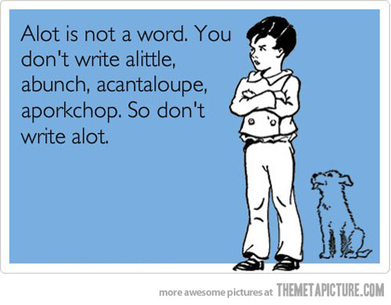
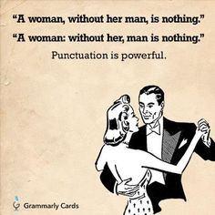
- Access to your Edublog site is mandatory

