Name: Serena Obeyd BLK: D
Penny Lab
Purpose: To determine how many drops of water fit on one side of penny.
Hypothesis: If the liquid placed on the penny decreases the surface cohesion, then the penny will hold less drops of water because of the surface tension. Some substances may reduce the cohesive force of water, which will reduce the strength of the surface skin of the water

Materials:
- Tweezers
- Eye dropper
- 8 pennies
- 8 paper towels
- 100 ml beaker with 50ml of soap solution
- 50 ml beaker with 25ml of water
Procedure:
Part A: Perform a CONTROL test for comparison with later results.

Step 1: Rinse a penny in tap water and dry completely.
Step 2: Place the penny on paper towel.
Step 3: Use an eye dropper to place drops of WATER on the penny (one at a time) until ANY amount of water runs over the edge of the penny.
Step 4: Record the number of drops for that trial in the table.
Repeat Steps 1 - 4 three more times before calculating your average.

Number of drops  TRIAL 1 | Number of drops  TRIAL 2 | Number of drops  TRIAL 3 | Number of drops  TRIAL 4 | AVERAGE Number of drops
17 | 26 | 16 | 33 | 23

Part B: Perform tests with the TESTING LIQUID.

Step 1: Start with a “clean” penny. Rinse the penny in tap water and dry completely. Be sure to remove as much residue as possible - without using soap!
Step 2: Hold the penny with the tweezers provided, then dip it into the TESTING LIQUID. Allow extra liquid
to drip off the penny into the container before proceeding to the next step.
Step 3: Place penny on dry spot on a paper towel. Place drops of WATER on the penny (one at a time) until ANY amount of water runs over the edge of the penny.
Step 4: Record your observations and the number of drops for that trial in the table.
Repeat Steps 1 - 4 three more times before calculating the average.

TRIAL 1 | TRIAL 2 | TRIAL 3 | TRIAL 4 | AVERAGE
7 | 9 | 8 | 5 | 7
Observations:
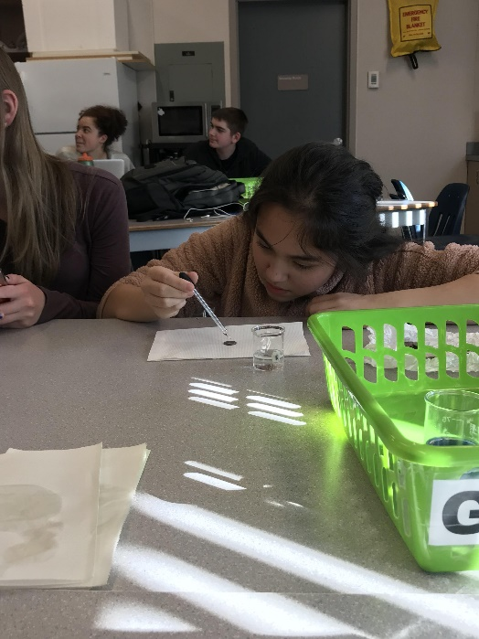  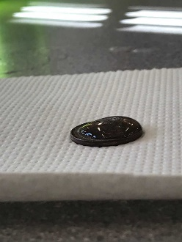  2Part One: Labelled Diagram  Beaker filled with water  Eye dropper  Water on penny | 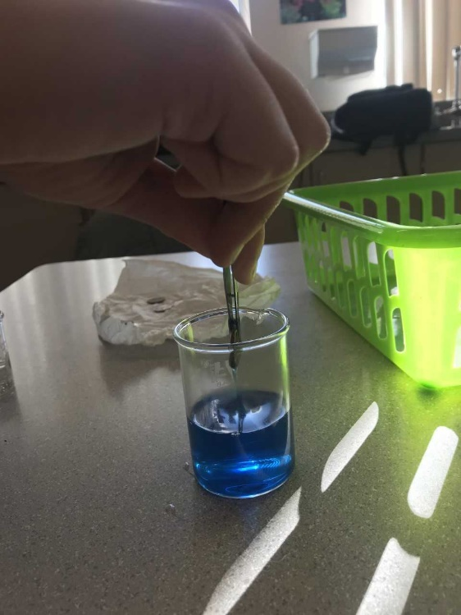  Part Two: Labelled Diagram of observations:  Liquid solution  Penny in liquid solution
Description:  - Water being dropped onto penny with an eye dropper | Description:  - Penny being dipped into liquid solution  - Same process with water being dropped onto penny with an eye dro
Results:
Group # | Average Number of water Drops on the Control Penny | Average Number of Drops on the  Penny submersed in the soap solution
Group One | 20 | 9
Group Two | 25 | 8
Group Three | 26 | 6
Group Four | 23 | 7
Group Five | 22 | 9
Group Six | 14 | 5
Class Average: | 22 | 7

Conclusion:

This experiment investigated how many drops of water could fit on one side of a penny and if a liquid solution would affect the number of drops. In order to study the problem, participants were asked to drop water on one side of the clean penny. Then asked to drop water on one side of the penny submerged in the liquid solution. This process was repeated 8 times, 4 times with a clean penny and 4 times with the penny submerged in the liquid solution.
Results showed that the class average of drops on a clean penny was 22 drops. The class average of drops on a penny submerged in a liquid solution was 7 drops. The results of each individual group were all close to the average drops for each section. Similarities were shown because of the fact that all groups used the same amount of water, liquid solution and other materials.
This proved that the hypothesis that if the liquid placed on the penny decreases the surface cohesion then the penny will hold less drops of water because of the surface tension was supported because some substances may reduce the cohesive force of water, which will reduce the strength of the surface skin of the water.
To extend this experiment, more types of liquid solutions should be tested. To extend it even further, use of other coins should be tested as well.
Finally, if the experiment was repeated, some changes to improve the experimental design could be to give more time to complete the lab. As the lab was rushed, more time being spent on dropping the water on the pennies would be useful.

