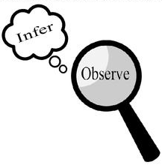
Observations and Inferences
Science 10 Name: Serena Obeyd BLK: D

OBJECT | OBSERVATIONS  Words that describe the object | INFERENCES  Ie: Where might the object come from? Possible uses? Etc. | QUESTIONS YOU HAVE ABOUT THE OBJECT
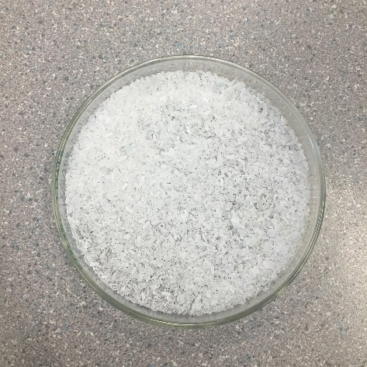 | - Very bright white color / transparent  - Small little bits varied in shapes (looks like sea salt)  - Faint smell of perfume  - Feels very rough and rigid  - Looks like tiny beads | - Could be crushed up crystals  - It could come from the mountains  - It could come from the ocean  - It may not be healthy for the environment  - Uses: maybe to make other objects | - Why does it smell the way it smells?  - Why is it crushed up into little pieces? Was it originally like that?  - Can it change color with heat?  - Can it be melted?  - Is it a type of drug?  - Can we buy this product? How much?
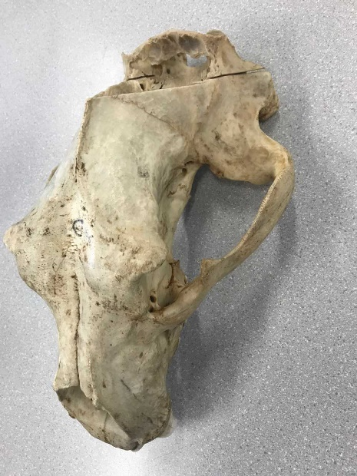 | - Brown and spotty  - Feels very hard – like a bone  - Looks a little broken down  - Holes throughout the skull like object  - Fairly heavy: a couple of pounds  - Sharp teeth (one broken tooth)  - No smell  - Teeth is whiter compared to the rest of the skull | - It might come from a different country  - Coming from an animal  - Could be a mammal creature  - Could be very dangerous due to the sharp teeth  - Could be old due to the size and coloration | - What type of animal is it?  - Where did it come from?  - Why is its tooth broken?  - Is it an adult skull or a baby skull – how old is the animal?  - Why is the jaw missing (bottom half)?
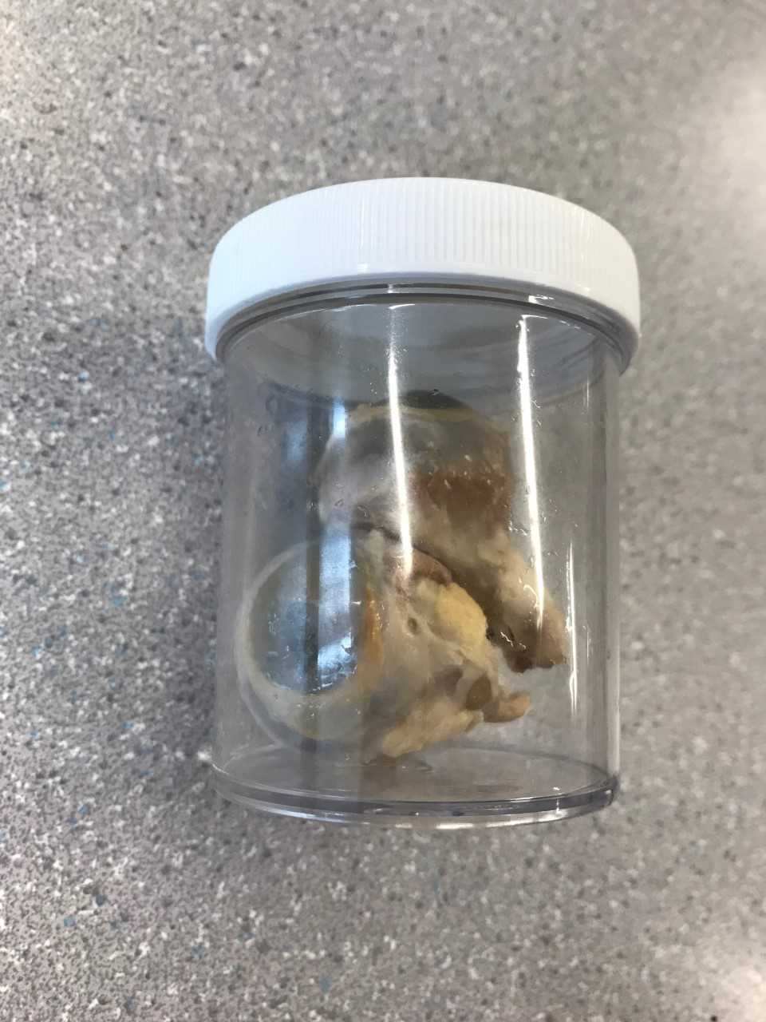 | - Fatty tissue  - Pink Veins  - Circular form  - Water in the container with the object  - Green clear color in the middle of the object  - Looks a little broken down | - Could be from a cow  - Could be dangerous  - It was preserved moderately well  - Taken from an animal | - What animal does it belong to?  - Why was it taken out of the animal?  - How long has it been since it’s been dissected?  - Is it harmful to the touch?
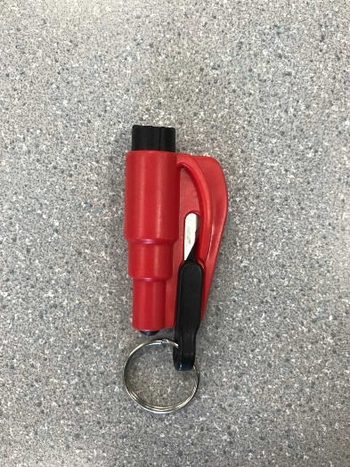 | - Has a ring  - Has a bright red color to it and black detailing  - Little bumps  - Blade like object on the inside | - Ring could be used to put on a key chain (to be carried around)  - Could be an emergency blade for emergency situations  - Dangerous to use  - Could be activated by pressing the black knobs | - Why is this object designed in such a way?  - Is it a harmful object?  - Is it useful for science?  - Is it used for emergency?

Observations/Inferences Assignment Assessment
Name: _____________________
Ex: Excellent VG: Very Good G: Good S: Satisfactory IN: Improvement is needed
Criteria | IN | S | G | VG | Ex
The following is included
- All 4 Images included
Observations:
- A minimum of 5 detailed observations made
Inferences:
- Thoughtful and logical inferences made
Questions:
- 2 thoughtful and logical questions made
- Spelling/grammar
- Assignment was completed on time
/10

