Float Your Boat Challenge
By: Serena Obeyd
Group Members: Melia, Kairi, Kane
Science 10 Block D

Problem: Make a boat that can float in water and hold the most amount of pennies

Hypothesis:
If the base of the boat is thick a squared, then the boat will be able to hold the greatest number of pennies because of the supported thick and squared base.

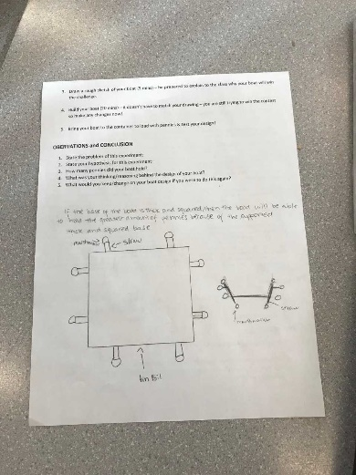
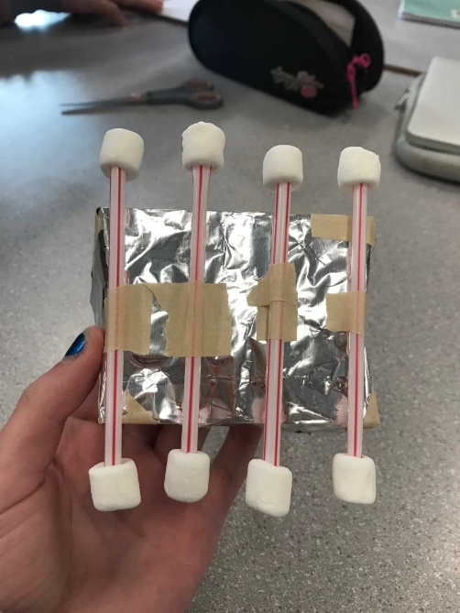
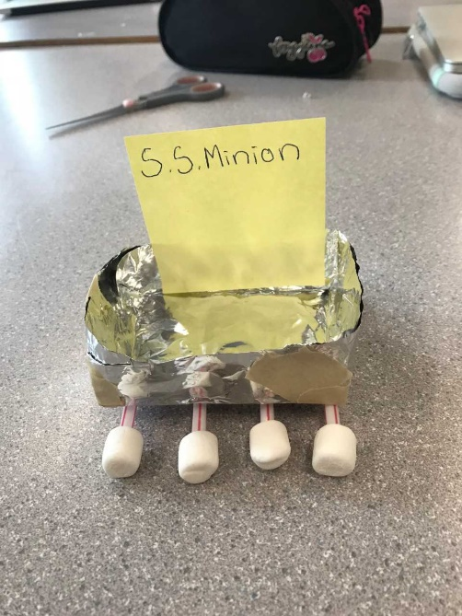
Observations:
Aluminum folded in to a squared shape boat, held together with tape
1 of the 8 marshmallows
Straws that have been cut in half
Bottom View
Top view

Results and Conclusions:
The boat held 45 pennies

The original thinking and reasoning behind the design was to make a squared shape boat with a stable base so that the pennies wouldn’t make the boat sink

If the following challenge was repeated, to improve the boat design, the following changes would be made… By making the base thicker, it would have given more support to the boat and would be able to carry more pennies. Also, one of the big reasons why the boat sank was because the inefficiency of the marshmallow placement. Two marshmallows from each side fell off during the challenge which imbalanced the boat. To improve the design of the boat, the marshmallows should be put into the straw more efficiently.

