Elements

The periodic table Memorizer:
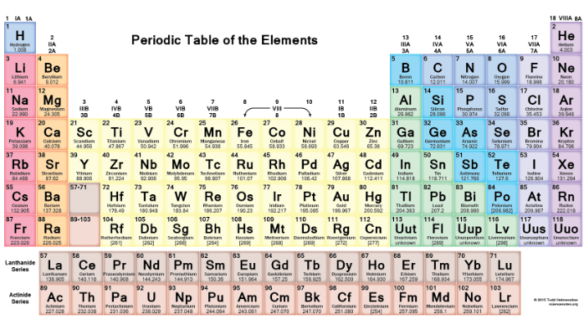
The memorizer is a useful tool to help you study for labs a test or just help memorize, the features of the app is that you can get the periodic table up without the symbols and elements and you must try and name as many as you can.

Define:
What this app help you memorize the elements of the periodic table. And also help you study for up coming tests or review if you don’t understand. Basically this app is fairly basic the main mode is when you sweep the periodic table so you just see the boxes and then you have to name all the boxes and if you cant don’t worry there is a answer key.

Deliver:
This app helps memorize the periodic table and it does a fantastic job of doing it, feel free trying it out if you would like. If you are having troubles with remembering the periodic table feel free to download this app because it helps a lot. If you do not want it to help you memorize the elements just feel free to use it as a periodic table as it allows you to zoom and it is also a hany tool to have just incase you don’t know what the abreviation for sulphur is.

Debrief:
After trying out this app and messing around with the settings I think it is a great app but I do not think I would use it as a simple google search would bring up the table. And also if you wanted this app to help you memorize I think that it’s a good app and I appreciate them trying but also remember I think that the easisest was to memorize the elements is just writing them down and just re-writing them until you memorize them. In conclution I think it is a great app but I do not think that I would use it in the futre.

