Safety First – A visual guide
Savannah
Block B

Two things to do incase of a Fire
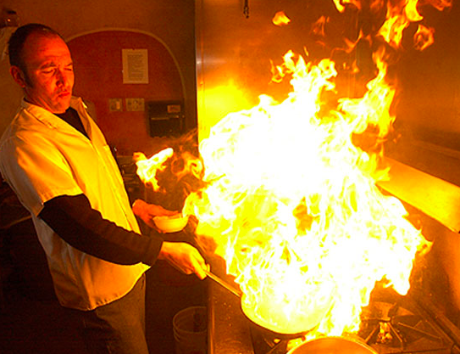
- To use a fire extinguisher
- Pour water onto the fire, unless it is an electrical fire then DO NOT POUR WATER ON THE FIRE!
Two ways to treat Burns/Scalds
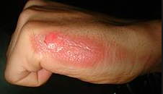
- Remove clothing or jewelry that may be in the way of the burn/scald
- Place burn under running cold water, but do not apply ice
Two things to remember when dealing with Chemicals
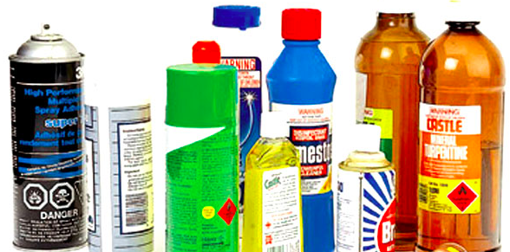
- NEVER mix chemicals together
- Keep chemical away from heat in the kitchen

Two ways to prevent Slips/Trips/Falls

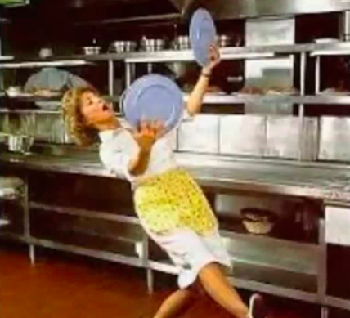
- Always keep kitchen floor clean (i.e. No water, boxes, diches etc.)
- Wear proper shoes, along with always having your laces tied.
Two ways to treat/prevent cuts in the kitchen
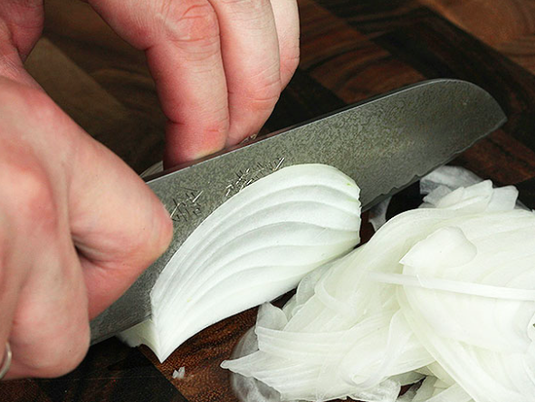
- Always have all your attention on the knife and food while you are cutting
- Keep knifes sharp
Two things to remember when lifting heavy items such as a bag of flour
- Always lift with your legs and never your back
- Take your time, do not rush. If you need a partner to help, just simply ask.

Two ways to Prevent Food Poisoning

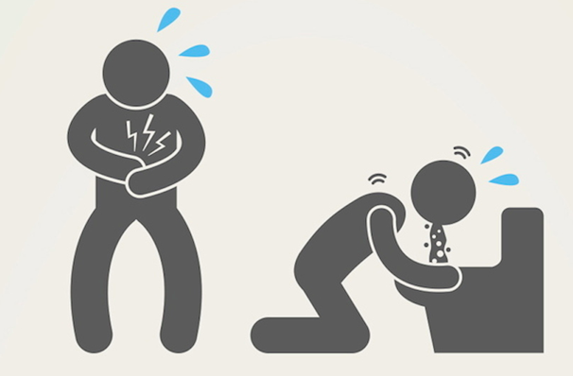

- Always wash your hands before eating
- Keep raw meat separate from cooked and always keep a clean kitchen

Two ways to properly use Waste Management
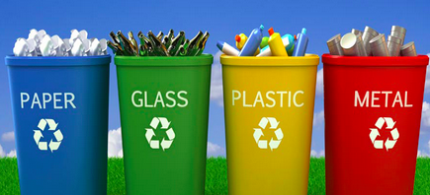
- Paper towels, timber and cardboard can all go into the compost bin, along with food scrapes of all kind.
- Don’t put recyclables in garbage.

Two ways to make sure you are staying hygienic while working in the kitchen

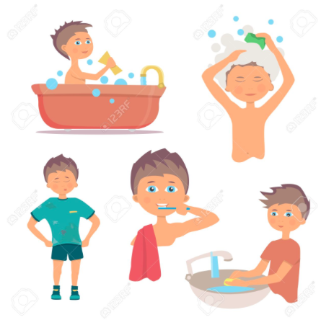
- Bath/shower regularly 1-2 times a day. Sometimes even 3 times.
- Keep fingernails clipped and always keep your hands clean by washing with soap and HOT water.

