
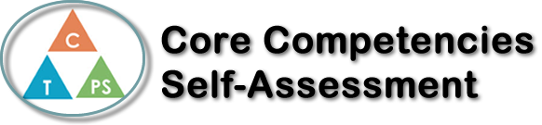
Name: sara khoja | Date: Jan.12,18

  How does the artifact you selected demonstrate strengths & growth in the communication competency?  In what ways might you further develop your communication competency? | Self-Reflection  Describe how the artifact you selected shows your strengths & growth in specific core competencies. The prompt questions on the left - or other self-assessment activities you may have done - may guide your reflection process.  I chose social competencies the best way to my understanding of develop  Is when it's happening around me. Knowing what’s happening in society and in school outside of school at home. Places and places and experience people can expedite is the best way for them to learn.  For example, when my parents aren’t I have to watch over my younger siblings its  They’re my responsibility for the evening. I've learned a lot from having responsibility on my shoulders and it really makes you grow as a person.  Our inquiry group project I enjoyed presenting it because  The presentation it self-has a message, symbolized society it self-acceptance is the key  To living happily as a person.  When I was younger 3 years ago I had to present my speech  I chose the topic ‘the dangers of social media I enjoyed presenting it, but I was sure nervous, awaring people of different dangers it didn’t just help me understand it also helped my classmates understand how dangerous technology is. It also helped me understand and remember what I was trying to make people understand.


How does the artifact you selected demonstrate strengths & growth in the thinking competencies?

In what ways might you further develop your thinking competencies?


How does the artifact you selected demonstrate strengths & growth in the personal & social competencies?

In what ways might you further develop your personal & social competencies?

Publish Your Self Assessment
You will now attach and/or embed your self-assessment to the bottom of the blog post with the artifact you have chosen. You may choose to make this post private or public. After placing your artifact on a blog post, follow the instructions below.
- Categories - Self-Assessment
- Tags - Now tag your post using the tag that corresponds to the competency that you have written about. You can choose more than one. Please use lower case letters and be exact.
  - #creativethinkingcc
  - #communicationcc
  - #criticalthinkingcc
  - #socialresponsibilitycc
  - #personalidentitycc
  - #personalawarenesscc
- Use the Add Document button located at the top of your post page and embed your self-assessment at the bottom of your blog post.
- Publish

