Float Your Boat Challenge
By: Sabrina Sharifzada
Group Members: Mabelle, Isaac, Flora, Sabrina
Science 10 Block D

Problem: To make a boat that would hold the most amount of pennies.

Hypothesis: If the structure is balanced then the boat would hold the greatest quality of pennies because it has a strong base.

Observations:
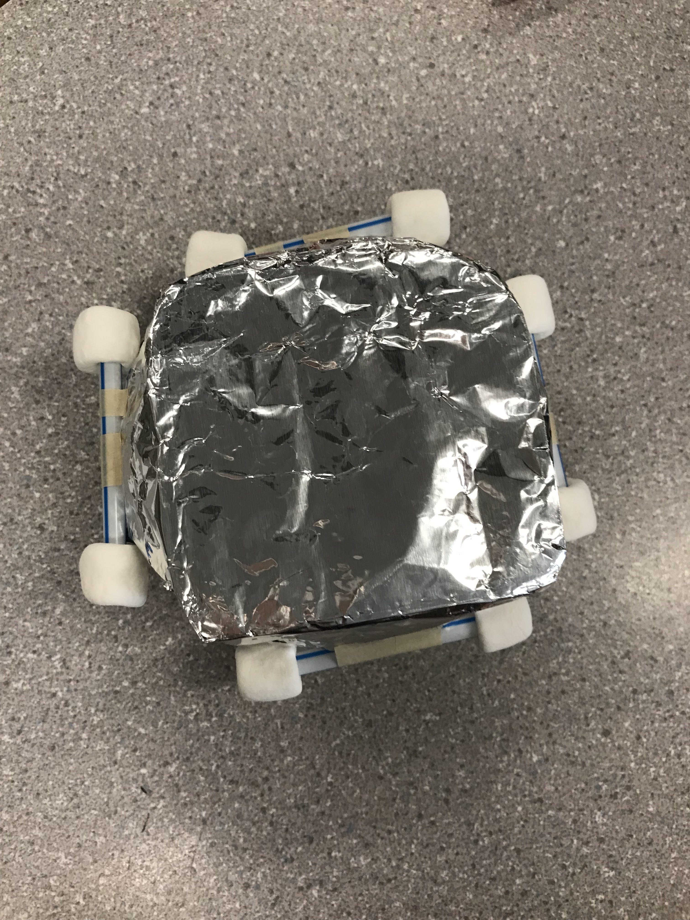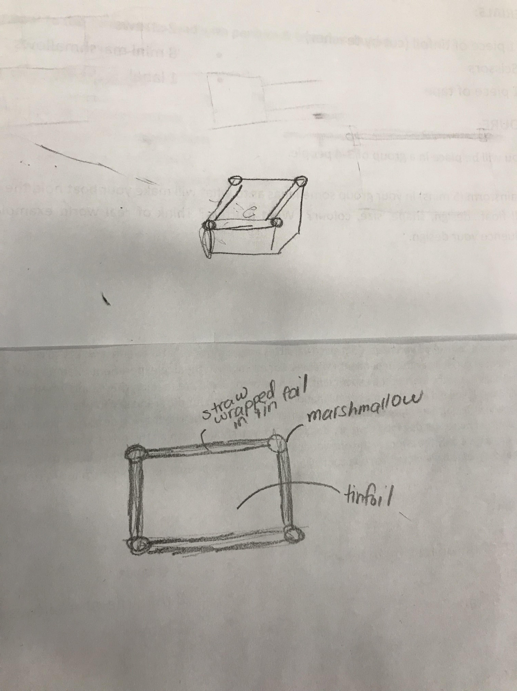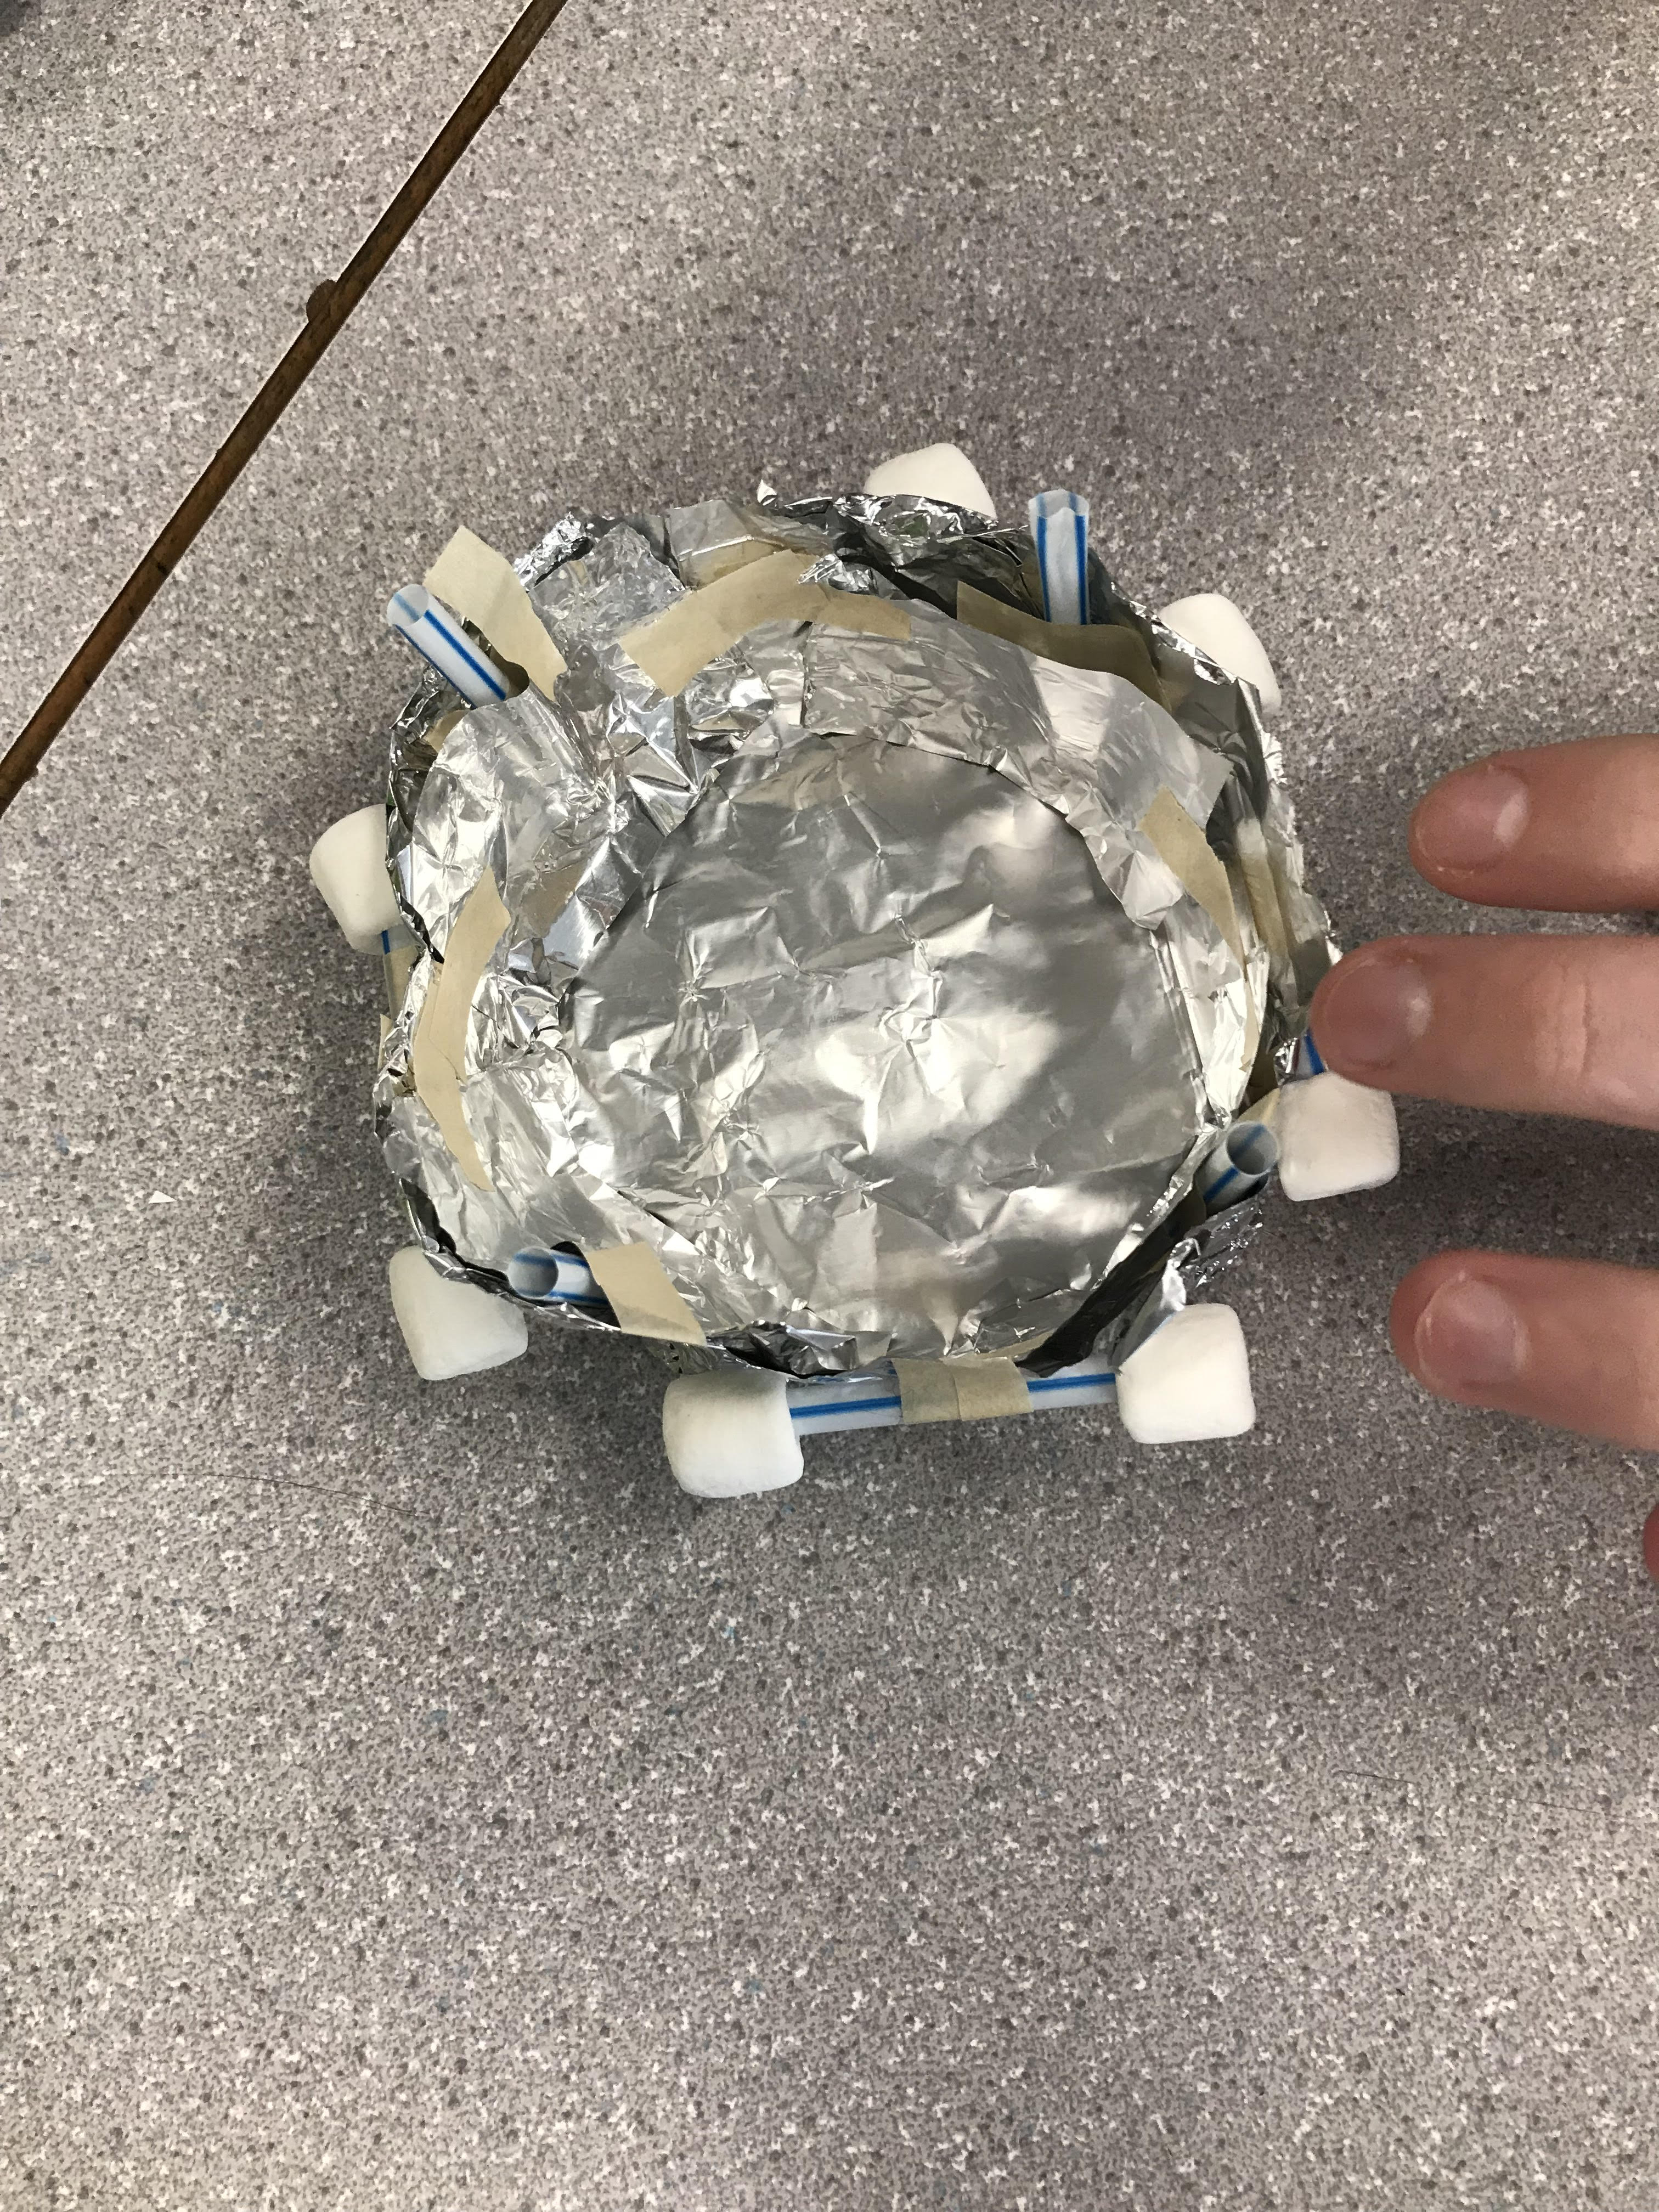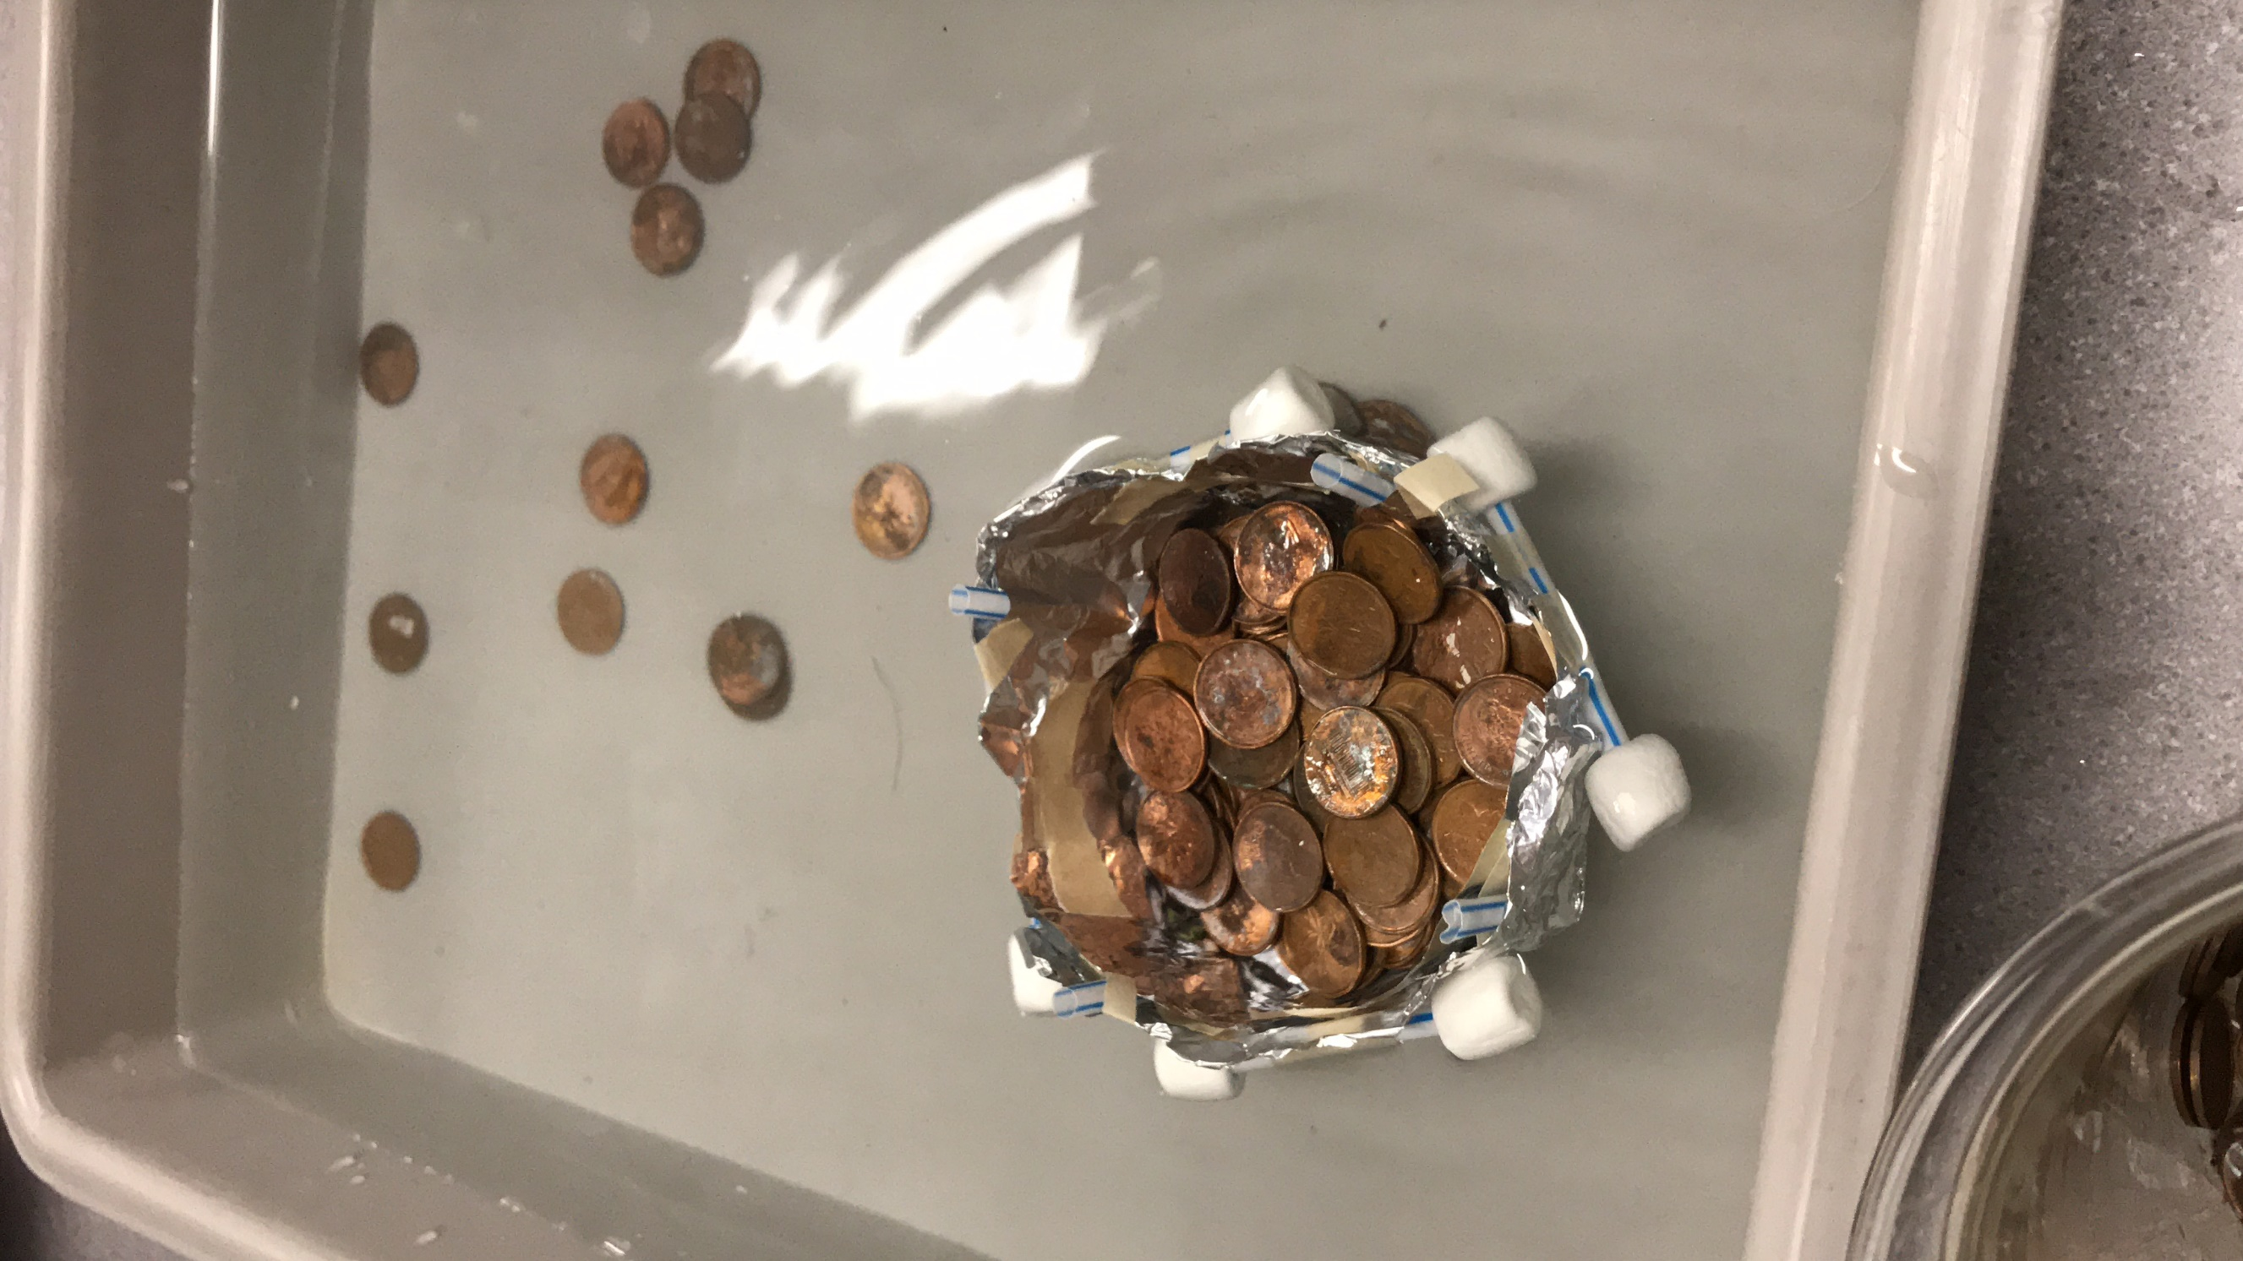

Bottom view drawing and plan inside/top view in water view

Results and Conclusions:
The boat held 101 pennies. Never knew that it could hold that much.

The original thinking and reasoning behind the design was…
- The marshmallows and the straws are the floating power, the tin foil was the base material and the tape would help make it sturdier. During the building, the marshmallows and the straws were placed in the middle so that when the boat was filled with pennies, it would still float until the water reached the middle.

If the following challenge was repeated, to improve the boat design, the following changes would be made:
- Double layer tin foil base (thicker)
- Make it more balanced (the straws and the marshmallows), they were a little of balance due to the limited time.
- If we had more tape, we would tape it more to make it more sturdy

Because that would help with the taking in more weight which means more pennies and it would be more balanced and even

Upload this document to your Edublog and Tag your post “floatyourboatdurandsc10blk_” add your block letter “C or D”
Independent variable: 1 variable that is changed

Dependent variable: responding variable, what you are measuring and it can be more than one thing (for example in the plant experiment, an ex) growth

Control(s): Variables that stay the same. Can be more than one.

