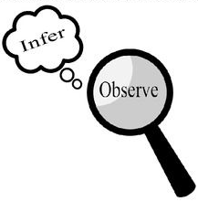
Observations and Inferences
Science 10 Name: Sabrina Sharifzada BLK: D

OBJECT | OBSERVATIONS  Words that describe the object | INFERENCES  Ie: Where might the object come from? Possible uses? Etc. | QUESTIONS YOU HAVE ABOUT THE OBJECT
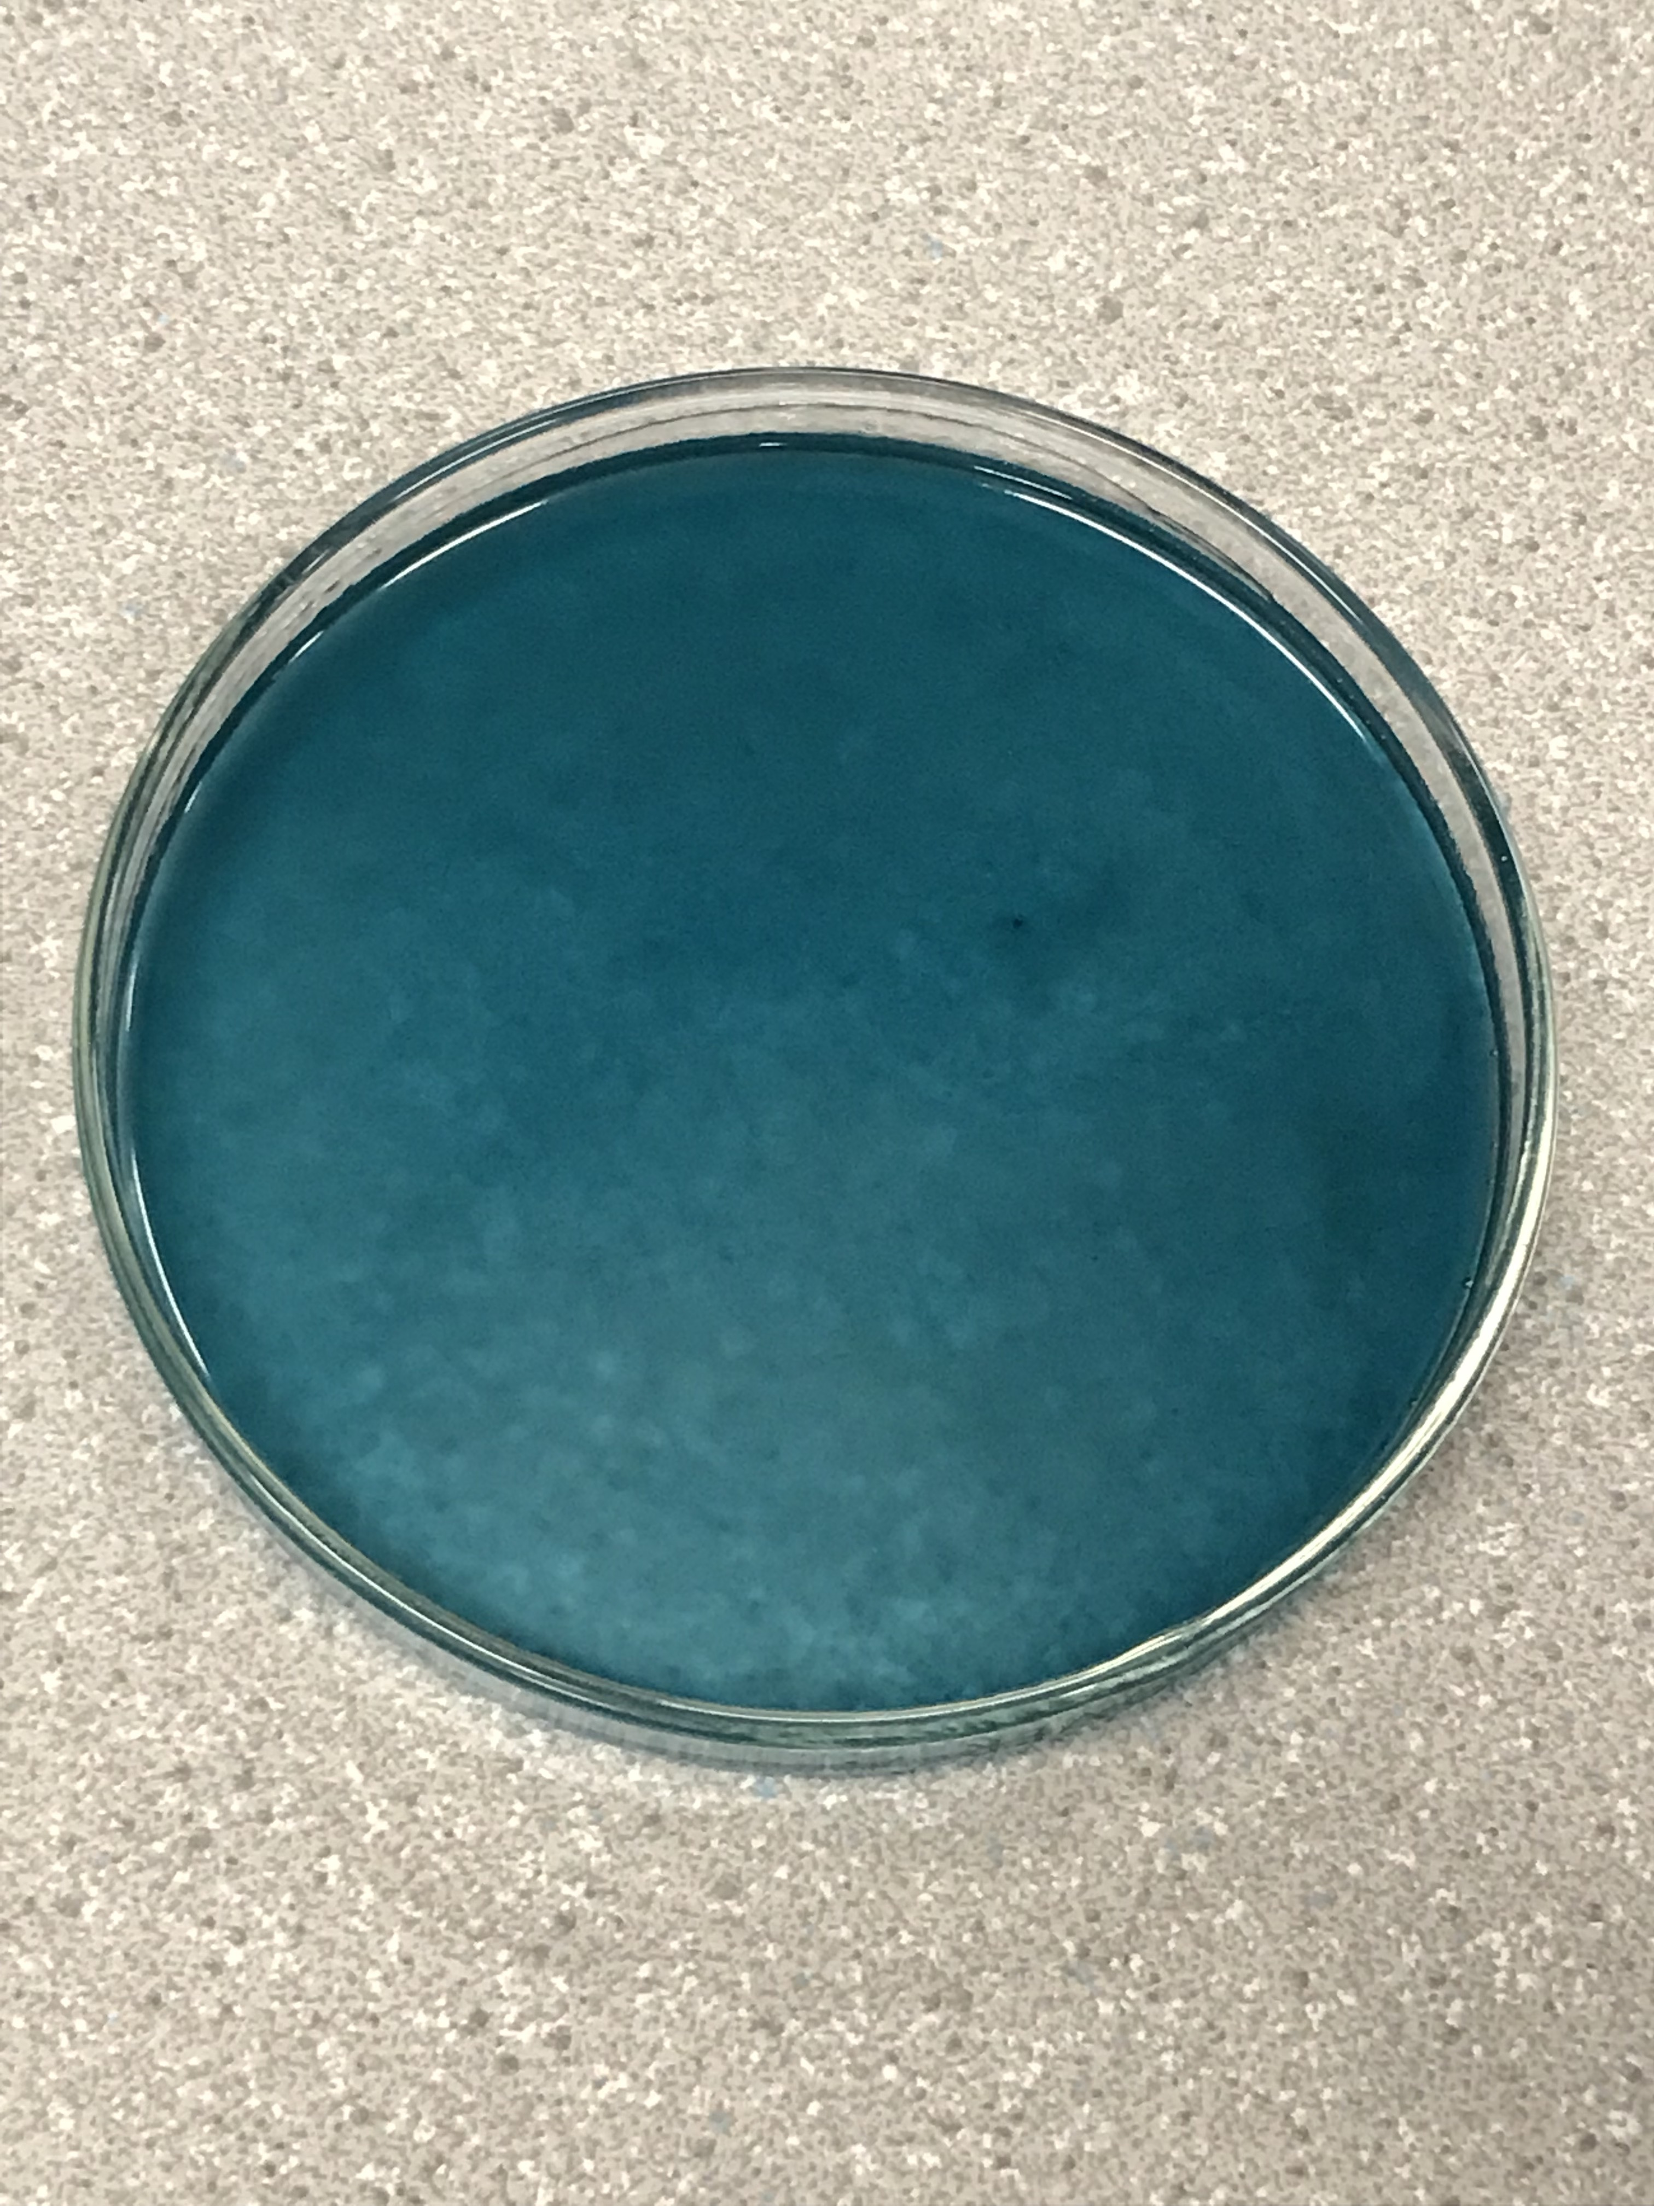 | - Blue/ turquoise  - Very liquidy  - Smells like fabric softener  - In a pea tree dish  - Not too thick  - Glossy  - Slimy looking | - Could be detergent based on the smell  - Can use it in washing clothing  - The colour is due to dye | - What is the use of colour in it?  - Ingredients?  - Is it edible?  - If this is laundry detergent, what is the brand?  - What makes it liquid?
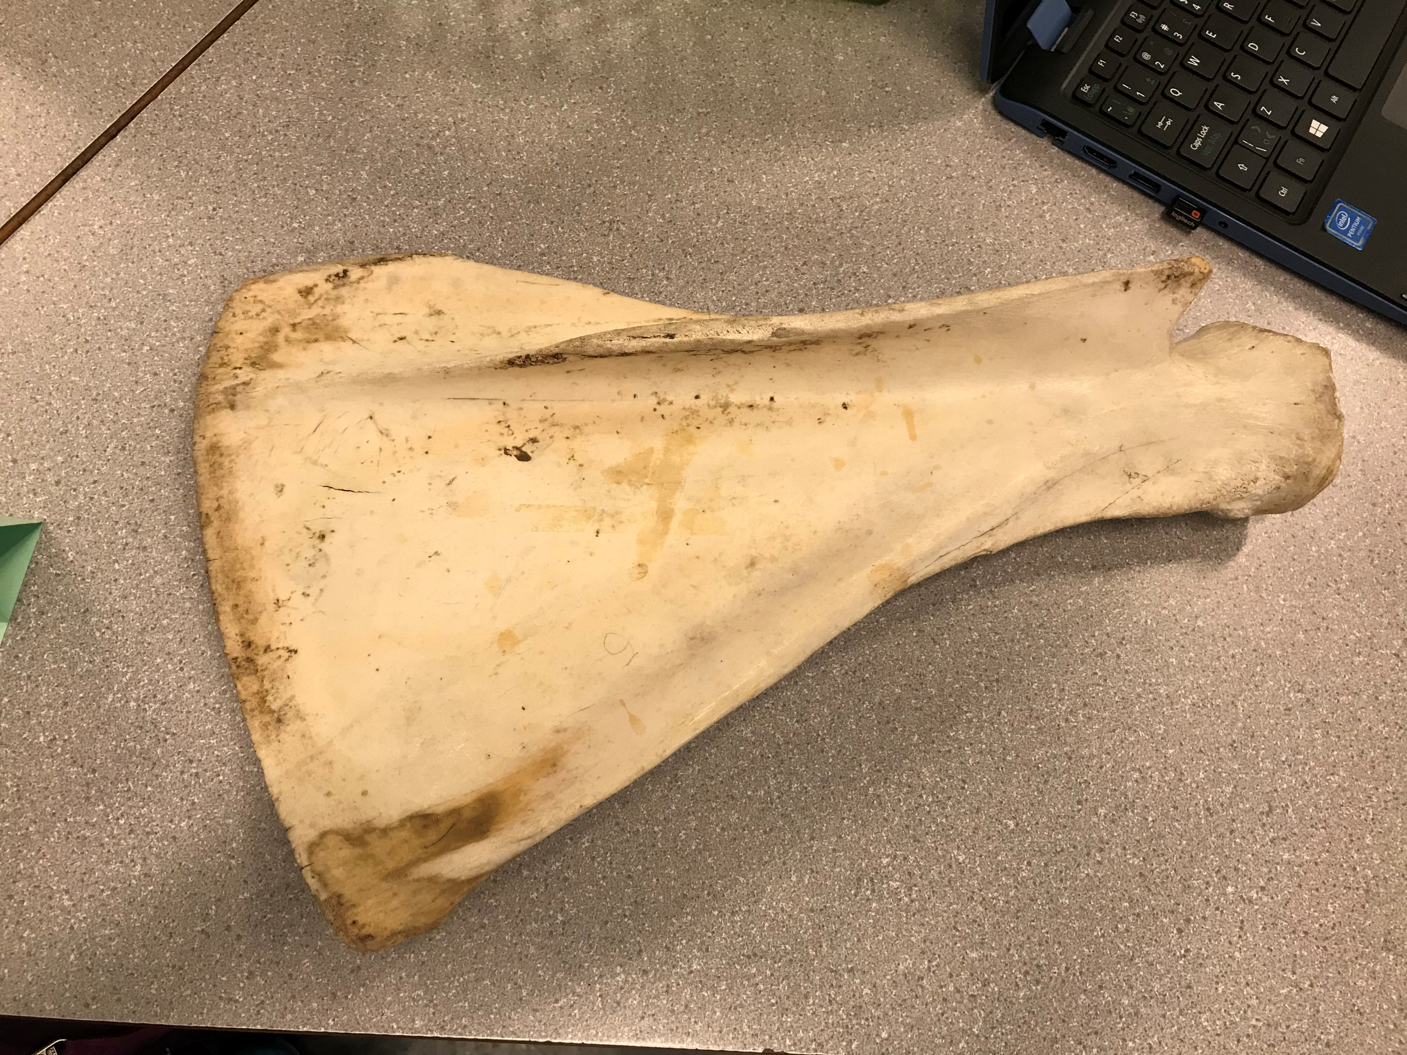 | - Looks like a paddle  - Cream, beige colour  - Hard  - Plastic/wood feeling  - Smooth in some areas and course in other  - Brown marks and a red mark  - Old  - Has little cracks | - Could be a fin from a aquatic animal  - Could be used as a paddle  - Bone  - Belongs to a large animal | - What animal did it come from?  - If it is from an animal, what part of it is it from?  - How old is it?
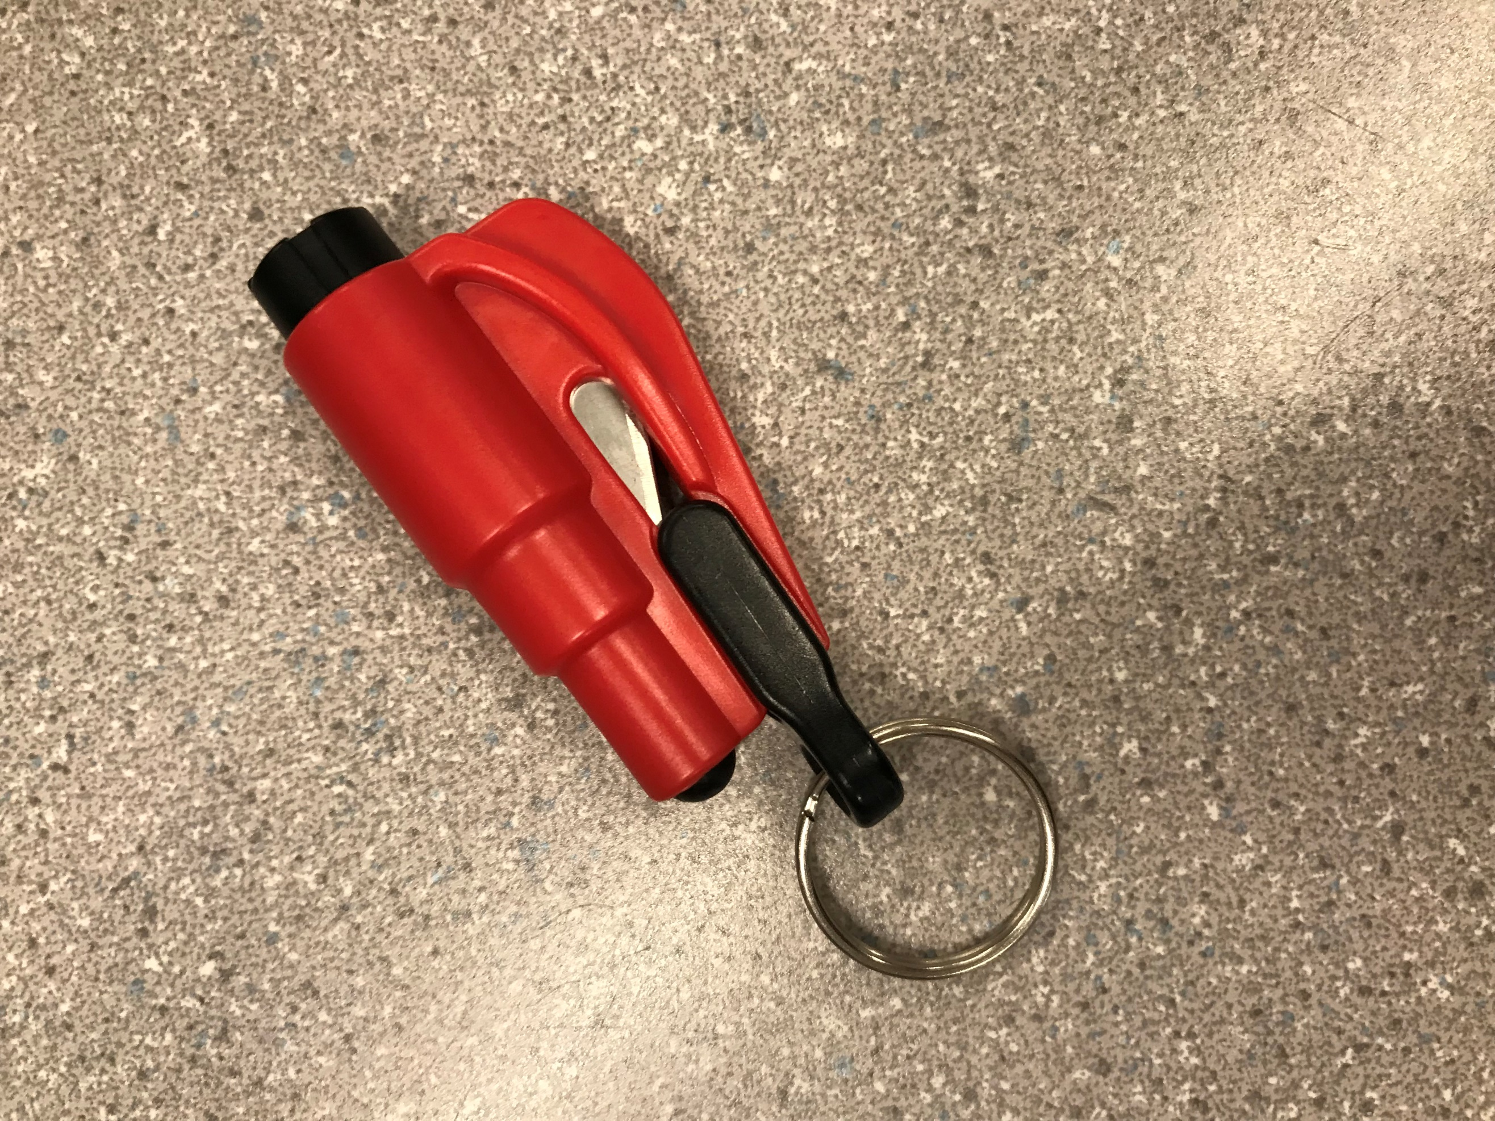 | - Has a sharp blade  - Red and black  - Has a key chain attachment  - Tough, hard  - Made of plastic | - Multipurpose tool  - Used for cutting things  - Can be attached to something (keys, bag, etc..)  - Dangerous  - Can be used when one goes camping | - What other things can it be used for?  - Why is made  - Where can you buy it
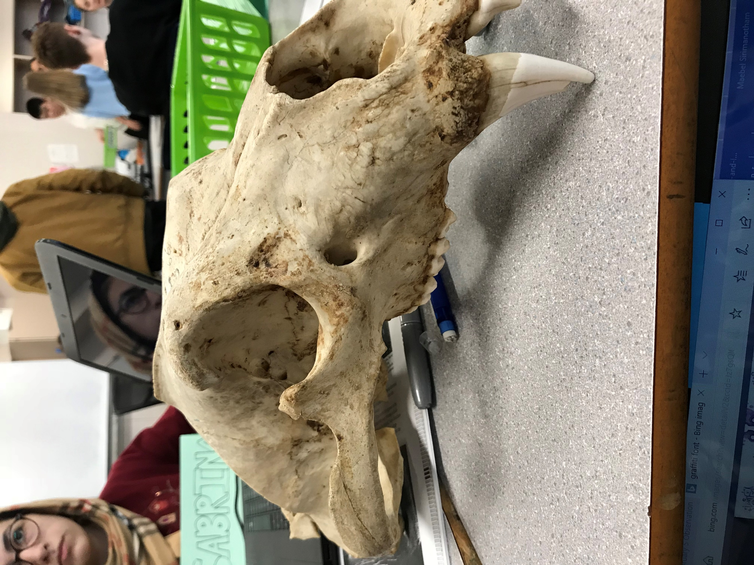 | - Skull  - Creamy colour  - Many spots  - Sharp teeth  - Many holes  - Animal with big head  - The brain has been taken out  - Hard | - Looks old  - Animal skull  - Can be used for décor  - Because the brain had been taken out, scientists or archeologist could have studied it | - How did people find it?  - What kind of animal?  - How old is it?

Observations/Inferences Assignment Assessment
Name: Sabrina Sharifzada
Ex: Excellent VG: Very Good G: Good S: Satisfactory IN: Improvement is needed
Criteria | IN | S | G | VG | Ex
The following is included
- All 4 Images included
Observations:
- A minimum of 5 detailed observations made
Inferences:
- Thoughtful and logical inferences made
Questions:
- 2 thoughtful and logical questions made
- Spelling/grammar
- Assignment was completed on time
/10

