Name: SAbrina sharifzada BLK: d
Penny Lab
Purpose: To determine how many drops of water fit on one side of a
penny.
Hypothesis: If the liquid placed on the penny decreases the surface cohesion, then the penny will hold less drops of water because the liquid will cause the water to slip.

Materials:
- 8 pennies
- 1 dropper
- 1 forceps
- 2 paper towels
- 50ml beaker of water
- 100ml beaker of soap solution

Procedure:
Part A: Perform a CONTROL test for comparison with later results.

Step 1: Rinse a penny in tap water and dry completely.
Step 2: Place the penny on paper towel.
Step 3: Use an eye dropper to place drops of WATER on the penny (one at a time) until ANY amount of water runs over the edge of the penny.
Step 4: Record the number of drops for that trial in the table.
Repeat Steps 1 - 4 three more times before calculating your average.

Number of drops  TRIAL 1 | Number of drops  TRIAL 2 | Number of drops  TRIAL 3 | Number of drops  TRIAL 4 | AVERAGE Number of drops
23 | 24 | 19 | 21 | 22

Part B: Perform tests with the TESTING LIQUID.

Step 1: Start with a “clean” penny. Rinse the penny in tap water and dry completely. Be sure to remove as much residue as possible - without using soap!
Step 2: Hold the penny with the tweezers provided, then dip it into the TESTING LIQUID. Allow extra liquid
to drip off the penny into the container before proceeding to the next step.
Step 3: Place penny on dry spot on a paper towel. Place drops of WATER on the penny (one at a time) until ANY amount of water runs over the edge of the penny.
Step 4: Record your observations and the number of drops for that trial in the table.
Repeat Steps 1 - 4 three more times before calculating the average.

TRIAL 1 | TRIAL 2 | TRIAL 3 | TRIAL 4 | AVERAGE
9 | 9 | 8 | 8 | 9
Observations:
Part One: Labelled Diagram of observations:  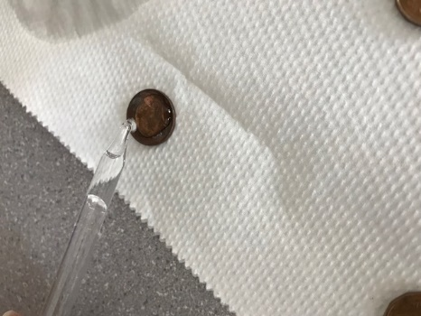  Without soap soloution | Part Two: Labelled Diagram of observations:  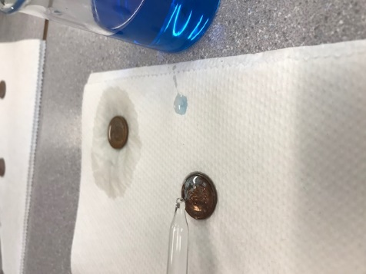  With soap soloution
Description:  - The water created a dome shape on the pennies without the soap solution.  - Took more drops of water before it spilled off the penny.  - When the water spilled, the towel absorbed more water  - Penny was rusty brown  - Water was transparent  - Penny was placed on top paper towel | Description:  - Took less water  - Water diluted the soap and the water got mixed in with the soap. Didn’t create a dome shape.  - The towel absorbed less water when the penny couldn’t hold anymore water.  - Afer the penny was dunked into the soap, the penny had a glossy blue coating of soap  - Penny was rusty colour  - Penny was placed on top of paper towel.  - Could lightly smell fresh scent of the soap solution.
Results:
Group # | Average Number of water Drops on the Control Penny | Average Number of Drops on the  Penny submersed in the soap solution
Group One | 20 | 9
Group Two | 25 | 8
Group Three | 26 | 6
Group Four | 23 | 7
Group Five | 22 | 9
Group Six | 14 | 5
Class Average: | 22 | 7

Conclusion:
This experiment investigated how many drops of water the Canadian penny could hold with and without the soap solution.

In order to, study the problem, the class was divided into different groups and each group performed the same experiment. Each group had to do 4(four) trials of dropping the water on the penny with and without the soap solution. Then each group had to calculate the average drops of water it held for the pennies with the soap and the pennies without the soap solution.

Results showed that the class average that a Canadian penny was able to hold with no soap solution was 22 drops of water. However, the penny that was submerged into the soap solution was only able to hold the class average of 7 drops of water.

This proved the hypothesis that if the pennies are placed in the soap solution then it would decrease the surface cohesion was supported because the soap solution wasn’t allowing the positive charged molecules of hydrogen and the negative charged molecules of oxygen to attract to each other as easily without the soap solution.

There is a big difference between Group five’s and Group six’s result for the penny without the soap solution. Probably, because Group six was dropping the water in just one specific area of the penny and another reason could be that they could have miscounted.

Group five’s and Group one’s results were exactly the same for the penny with the soap solution probably because the pennies had the same amount of soap left on them after it was dunked into the soap and also because they could have dropped the water at the same pace.

To extend this experiment, dry laundry detergent could have been mixed with different amounts of water to see if that affects the surface tension or the cohesion instead of just liquid detergent. Different metals also could have been used to see if the metal has any effect on the amount of drops it can hold.

Finally, if the experiment was repeated, some changes to improve the experimental design could be to have two forceps instead of just one, because it was difficult to pick up the pennies since it would move when trying to pick it up. Other than that, there wasn’t anything that should absolutely be changed.

Post 2 photos (penny with water only and penny with testing liquid) and your conclusion to your edublog site. Tag “Science10pennylab_Feb2018”

