Junk Food Project
Coffee Crisp (50 grams): It is easy to eat, yet packed with sugar and sweetness. It also has the right amount of the coffee flavour to get it to the next level.
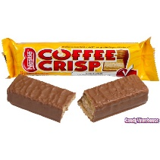
https://www.fatsecret.ca/calories-nutrition/nestle/coffee-crisp-(50g)/1-bar
https://www.madewithnestle.ca/coffee-crisp/coffee-crisp-0
Additives: soy lecithin, cocoa mass, sodium bicarbonate, polyglycerol polyricinoleate,
Condiments: Coffee, sugar, cocoa ingredients,
Ingredients: sugar, modified palm, sunflower and or safflower oils, wheat flour, modified milk ingredients, cocoa butter, cocoa mass, soy lecithin, coffee, sodium bicarbonate, lactose, cocoa, yeast, polyglycerol polyricinoleate, natural flavours.
Calories and quantity: 260 calories, 13g of fat, 34 carbs, 3g of protein per 50g of coffee crisp (1 bar)

Chubby Chicken Burger: Quick and easy to eat but crispy and delicious in every bite.
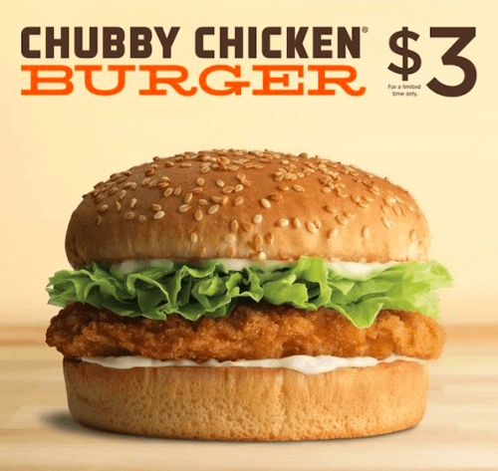
https://www.fatsecret.ca/calories-nutrition/a-w-restaurant/chubby-chicken-burger/1-serving
https://www.aw.ca/foodfacts.nsf/NutrientsByRef/EE71522F0CE8C67488256DF0007E9A82?opendocument

Additives: soy protein isolate, monosodium glutamate, sodium tripolyphosphate, disodium inosinate, disodium guanylate, dextrose, guar gum, calcium propionate, monoglycerides, sodium stearoyl-2-lactylate. calcium carbonate, calcium sulphate, ammonium chloride, potassium sorbate, acteylated tartaric acid esters of mono and diglycerides, monocalcium phsophate. concentrated lemon juice, calcium disodium EDTA.
Condiments: salt, spices, sesame seeds, , vinegar, sugar, Lettuce, mayonnaise
Ingredients:
Components:
Breaded Chubby Chicken® portion, sesame seed bun, mayonnaise, lettuce
Details:
Chubby Chicken® Portion: chicken breast portions (boneless, skinless), water, soy protein isolate, monosodium glutamate, sodium tripolyphosphate. Battered and breaded with wheat flour, toasted wheat crumbs, salt, spices, disodium inosinate, disodium guanylate, yellow corn flour, corn starch, dextrose, guar gum. Browned in vegetable oil
Sesame Seed Bun: enriched flour, water, glucose-fructose/sugar, *yeast, sesame seeds, vegetable oil (Canola or Soybean), salt, calcium propionate, monoglycerides, sodium stearoyl-2-lactylate. May contain wheat gluten, vinegar, calcium carbonate, calcium sulphate, ammonium chloride, potassium sorbate, acteylated tartaric acid esters of mono and diglycerides, monocalcium phsophate. *Order may change.
Mayonnaise: canola oil, water, liquid whole egg and yolk, salt, vinegar, sugar, spice, concentrated lemon juice, calcium disodium EDTA.
Lettuce:

Calories and quantity: There are 480 calories, 26g of fat, 44g carbs, 21g potein, per 184g (1 chicken burger)

Doritos: Doritos is a yummy and quick snack that you can have anywhere. Every bite gives you a cheesy and salty taste.
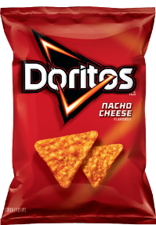
http://www.fritolay.com/snacks/product-page/doritos/doritos-nacho-cheese-flavored-tortilla-chips

Additives: maltodextrin, monosodium glutamate, dextrose, dosodium inosinate , disodium guanylate.
Condiments: salt, cheddar cheese, romano cheese, tomato powder, spices, sugar, garlic powder, bell pepper powder,
Ingredients:
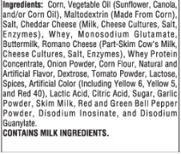
Calories and quantity: 140 calories, 8g of fat, 16g carbohydrate, 2g of protein per 28 grams (about 11 chips)

Results:
Chubby Chicken Burger:
Out of the all the junk food that I listed, the chubby chicken burger is the most unhealthy even though when you look at it only contains lettuce mayonnaise, chicken and the bread. Mainly because of the number of additives it includes and then the calories and the fat. The reason I like it is because there is a flavour explosion in your mouth when you bite in to it, probably because of the fat content.

Additives and what they are used for:
maltodextrin, | Stabilizer, thickener and sweetener
, dosodium inosinate | Flavour enhancer
disodium guanylate. | Flavour enhancer
soy protein isolate | Chemical that is not good for you
, monosodium glutamate | Flavour enhancer
, sodium tripolyphosphate  https://www.chefsteps.com/ingredients/sodium-tripolyphosphate#/! | Sodium tripolyphosphate (STPP) is an alkaline salt that will raise the pH of meats and seafood, enough to increase their water-holding capacity.
guar gum | Thickening and stablizing
calcium propionate | Prevents mold to form in food
, monoglycerides | Emulsifiers; binds liquids
, sodium stearoyl-2-lactylate | Emulsifier and stabilizer
. calcium carbonate, | Helps to reach the calcium requirements
, calcium sulphate, | Is a salt used to make casts and plasters
ammonium chloride | Used as yeast in baked products
, potassium sorbate | Prevents bacteria in food
, acteylated tartaric acid esters of mono and diglycerides,  http://bakerpedia.com/ingredients/datem/ | DATEM is an emulsifier used in bread making to strengthen the dough during processing. It helps improve texture and increase volume in a variety of products
monocalcium phsophate. | Leavening agent
: soy lecithin | Emulsifier and helps things not separate
sodium bicarbonate, | Leavening agent and AKA baking soda
, polyglycerol polyricinoleate | Emulsifier

