Math 9 Finance Project Name ___________________
You are now in the workforce! Starting your first salary job and living on your own. The purpose of this project is for you to determine income tax, CPP and EI deductions and to see the work that goes into creating a budget for a single individual. This document is the first step and is due on Wednesday June 6. Show all your calculations below and post any photos requested.
Here are your tasks:
- Your yearly gross income is: __36,187______________
- Use your yearly gross income (GI) and find your monthly GI.

______3,016__________________
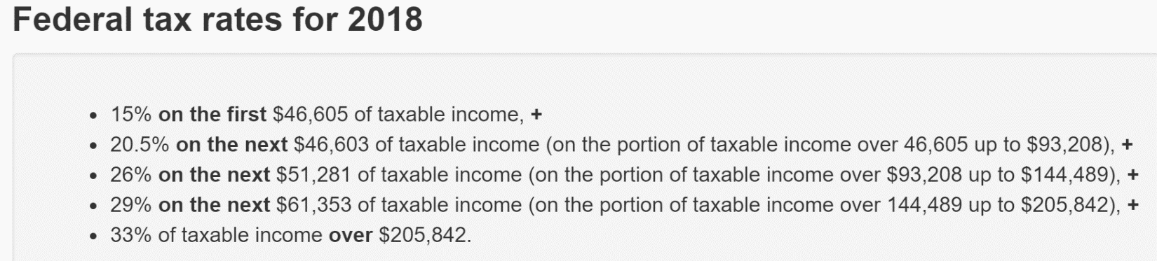
- With your given yearly GI, determine your federal tax rate deduction using the table below:

__30,759______________________
- Divide your federal tax rate by 12 to get your monthly deductions.

_____2,563___________________
- With your given yearly GI, determine your provincial tax rate deduction using the table below:
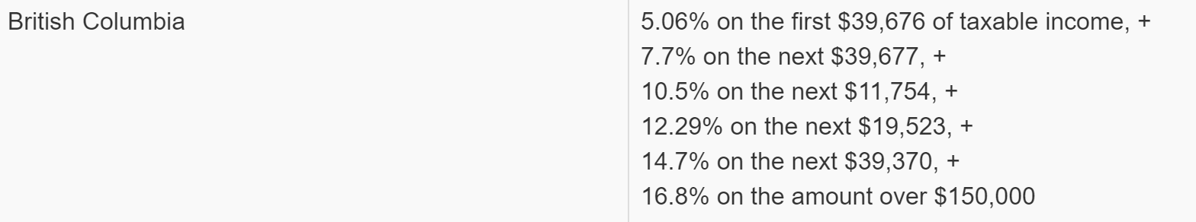

___29,203_____________________
- Divide your federal tax rate by 12 to get your month deductions.

_2,434_______________________
- With your given GI and the steps below, determine your CPP deductions:
  - Divide $3,500 by 52.

___67_____________________
  - Divide your yearly GI by 52 (this is your weekly GI)

__562______________________
  - Subtract (a) from (b)

____495____________________
  - Calculate 4.95% of the number in (c).

__28______________________
  - Multiply (d) by 4. This is your monthly CPP contribution.

_______112_________________
- The EI deductions are $858.22 annually (per year). Determine your monthly EI deductions.

__2362______________________
- Using your monthly GI (from #1) and your deductions from #3, 5, and 6e, determine your net income.

________________________
- Find a place to rent from: https://vancouver.craigslist.ca/search/pml/apa.
  - Conditions for the rental: https://vancouver.craigslist.ca/pml/apa/d/1-bedroom-on-1st-floor-of/6611365289.html
    - Must be in the tricities: Coquitlam, Port Coquitlam and Port Moody
    - You will likely need a roommate. The number of people living in the place must be equal to the number of bedrooms. (eg. A 2 bedroom apartment = 2 people)
  - Take a screenclip of the place you are going to rent and post it below. Screenclip should include:
    - A photo of the rental
    - The price
    - Conditions of the rental (what’s included, what isn’t)
Determine your monthly rent based on the price and the number of people living there.
- Based on your current cell phone usage (ie. data, minutes used per month) find a plan that fits your needs. Include the plan below. Find the plan’s monthly price, including tax (PST and GST is a total of 12% in B.C.)
- Ask your family how much they spend on food each month. Use that to determine the monthly food budget for one person.

