READING JOURNAL
Title: to kill a mocking bird
Group members: Molly, Cristina, Henry, Alhan, etc…
Date: may 22  Pages:3-66  Role:  - Research  - Plot  - Character  - Style  - Questionner | TYPE YOUR COMMENTS HERE….ADD IMAGES, MAPS, WHATEVER IS NECESSARY  Include page references  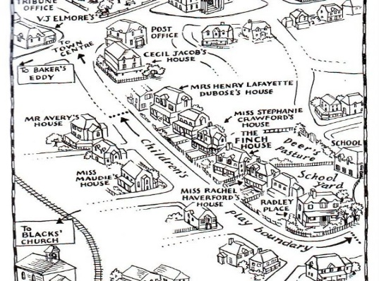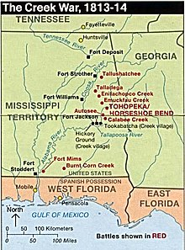  To Kill a Mockingbird takes place in Maycomb, Alabama, during the 1930’s. It is a fictional southern town of Alabama, separated from the rest of society: “There was no hurry, for there was nowhere to go, nothing to buy and no money to buy it with, nothing to see outside the boundaries of Maycomb County.” (Lee 10). Maycomb County is an old town, with unchanging beliefs; divided by family status, and racism: “The sheriff hadn’t the heart to put him in jail alongside Negroes, so…” (Lee 11). Maycomb was Christian town, stuck in it’s beliefs, and unable to grow as a city: “Maycomb was an old town, but it was a tired old town when I first knew it.” (Lee 6). The first Finch arrived in Maycomb during the Creek War, which happened between 1813-1814, meaning the town at that point, was at least 110+ years old. “…Because of Simon Finch’s industry, Atticus was related to nearly every family in town…” (Lee 6). You can infer that since the first Finch was a settler from war, that many of the townsfolk settled around the same time, probably many of them fought in the Creek War (which did take place in the southern united states). Based off Scout’s description, and the general climate of Alabama, “In rainy weather the streets turned to red slop…somehow it was hotter then…” (Lee 6), we know that the town is hot, and humid, with high levels of precipitation. It was also a small enough town, with low levels of crime: “His (Atticus) first two clients were the last two persons hanged in the Maycomb County Jail…” (Lee 5), meaning that everyone knew everyone’s business: what they did, where they went, and all the rumours about them.
Date: 05/27/18  Pages: 67-132  Role:  - Research  - Plot  - Character  - Style  - Questionner | Page 72-“Mr. Radley shot at a Negro in his collard patch.” (Lee 72) Why did Miss Maudie (everyone) assume that it was a Negro in Mr. Radley’s Yard?  Maybe it was, in that time, easier to see a ‘Negro’ as a criminal, rather than look closer at our own ‘people’. Humans, in general, fear differences, and change. I believe that because of the prejudices in this society, having a guilty ‘Negro’ as the culprit, instead of an ‘innocent’ white man (or child), was easier for them to deal with. The thinking that another ‘Negro’ had committed a crime, fulfilled their thoughts- confirming their beliefs, especially in this unstable time of Atticus starting to challenge the system; unrelenting in his pursuit to defend a black man, in a white vs black society.  Page 83- Why did Mr. Radley fill the knot-hole with cement?  Maybe because he didn’t want his brother to have any freedom/communication with the outside world. I feel like Nathan was possibly trying to control Boo as much as possible and decided cutting of his only means of communications with Scout and Jem. I also felt like he was maybe jealous of the attention Boo was giving to the children, when he had been Boo’s sole contact for so many years. However, maybe it was because he wanted to protect him. Boo had been thought of as a threat, because of what he did, but also fear of the unknown. If the townsfolk had discovered that Boo was in contact with the children, it could get them in trouble, but also him.  Page 127- Why did Atticus have to be the one to shoot the mad dog? *We discussed this in the group  Maybe because Atticus was the only one in the town that was strong enough to deal with the mad dog. Throughout the book, Scout talks about how ashamed she was that her father was old weak: “This modest accomplishment (Jew’s harp) only served to make me more ashamed of him.” (Lee 120), however, we are starting to see that his strength lies in being strong enough to do what no on else in the town could; defeat the ‘mad dogs’ of Maycomb. We discussed that the dog was a symbolism for racism, that when they said Atticus was the only one able to make the shot, it was because he was only one in Maycomb that clearly saw what racism was doing to the town (plaguing it, just like Tim Johnson; making everyone sick), and had the inner strength to try and help the town to overcome it.

Connection to Inquiry Question
Name: Ryann
Question: What effect does racism have on a person/culture?
Connection to Inquiry Question

Find one non-fiction source that also answers your question. Look for a source from a reputable news site such as CBC, CTV, Macleans, Global News, an Encyclopedia, The Vancouver Sun, The Province, Globe and Mail, or The National Post. Be sure to include quotes.

Source 1: News site
Question : What effect does racism have on a person/culture?
Title of the news source: CBC News

Title of the article: 2 former Forces members say racism forced them out of the military

Author: Preston Mulligan

Citation (use EasyBib or Citation Machine):
Mulligan, Preston. “2 Former Forces Members Say Racism Forced Them out of the Military | CBC News.” CBCnews, CBC/Radio Canada, 8 May 2018, www.cbc.ca/news/canada/nova-scotia/2-former-forces-members-say-racism-forced-them-out-of-the-military-1.4652129.
Notes (summarized and paraphrased):

• Two black men, and two other members of the Canadian forces, are launching a lawsuit against the Forces for continued and “systemic racial discrimination and harassment”.
• Wallace Fowler and Rubin Coward both claim to have PTSD (Wallace Fowler never went into active combat) from the unfiltered racism they received, even after they filed reports.
- Fowler says his family was also racially attacked while living on CFB Esquimalt
- Claimed to not have any serious health issues before he joined the armed forces, only afterwards did he start to have “serious and deteriorating psychological illnesses”
- He was discharged in 2004, because he was “not advantageously employable.”
- Coward says he got into a fight with a man after having walked into the base’s mess hall with two white women.
- Both men moved bases, however the discrimination and racism followed them.
- Both men filed lawsuit for their discriminatory mistreatment over the years
The answer to the question:
Racism is ever-present in our society, people, culture, even our government and military. We think of it as something that can happen to everyone, and there isnt anything we can do about it: “…He reported the abuse to a superior officer, but was told to either put up with it, or leave the Forces.” (Mulligan). However, in this article we see that racism can cause long-lasting health effects. PTSD is “triggered by a terrifying event- either experiencing it or witnessing it.” (www.mayoclinic.org). Racism triggers extreme anxiety in its’ victims, incites deep anger in its’ targets, and can mentally dilapidate those it affects: “After months of ridicule and isolation, Mr. Fowler was diagnosed with serious and deteriorating psychological illness…none of which were present at the time he enrolled in the Canadian Armed Forces.” (Mulligan), “I said to my wife, I was the angriest black man in Canada.” (Mulligan) “He’d served in Israel, Syria and Germany, but said it was racism in the Forces that brought on his post-traumatic stress disorder.” (Mulligan). Even though it is a common occurrence, that doesn’t mean that it’s effects are common. Racism ended the careers of two men in the forces, and however many more that weren’t mentioned in the article. It gave these men serious health effects, that left-unchecked, could’ve, and can, ruin their lives.

Now find a literary source that answers the question. This can be a movie, book, short story, poem, spoken word or song. Be sure to include quotes.

Source 2:

Source genre:

Title:

Author/director:

Citation:

Notes (summarized and paraphrased):

•
•
Source 2: Short Story (Example)
Title: “Red: A Crayon’s Story”
Author: Michael Hall
Citation: Hall, Michael. Red: A Crayon's Story. New York, NY: Greenwillow , an Imprint of HarperCollinsPublishers, 2015. Print.
Notes:
- Red crayon has a bright red label but he is actually a blue crayon
- Everyone tries to help him be “red”
- His mother says, “Go play with yellow so you can make orange”. (pg. 5) His mother does not accept who the crayon really is and tries to change him by encouraging the “right” friends
- His friends try and “fix” him such as scissors and tape. Scissors thinks, “maybe your label is too tight,” (pg 7) and tries to cut it so he can breathe. This is a play on words as one may feel “suffocated” by their label.
- Red is miserable as he cannot be himself. (insert quote here)
- He meets a new friend that has a new perspective and encourages Red to be who he is- blue! His friend allows him to express himself how he wants and it works.
- This story shows that labels do not show who one is. It is important to be true to yourself.

