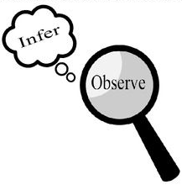
Observations and Inferences
Science 10 Name: BLK:

OBJECT | OBSERVATIONS  Words that describe the object | INFERENCES  Ie: Where might the object come from? Possible uses? Etc. | QUESTIONS YOU HAVE ABOUT THE OBJECT
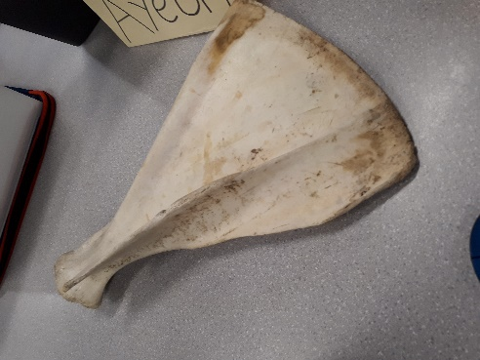 | - The bone is very thin and flat  - it is a joint of some sort  - there is still some sort of debris on it from when it was alive | - it is from a rather large animal  - it is not prehistoric  - it could be some sort of fin of perhaps a dolphin or shark | - what animal is this bone from  - how old is it  - is this a land or water animal?
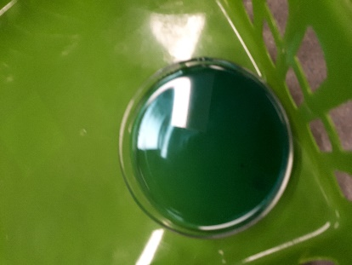 | - it is a greenish blueish thick liquid  - it smells like some sort of soap | - it is laundry detergent  - it comes from a larger bottle or container  - it could be a dish soap | - what brand is it  - what different things can it be used for  - what exact scent is it made to smell like
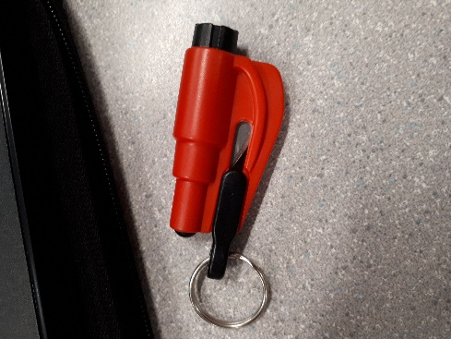 | - it is black and red with a blade which is restricted from being used by some sort of safety guard  - it has a button on the top that you can press in | - it could be used to cut something in perhaps in a survival situation  - you keep it with you on like your key chain  - the blade pops out when you press the button | - what happens when you press the button on the top of it?  - What type of material can you cut with the blade (is it heavy duty or for things like thread?)
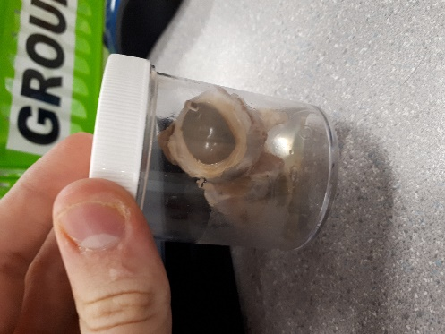 | - It is the eyes of a larger animal  - It is not fresh it has been kept in the container for a long time  - It is very discolored from when it was fresh | - It is from a large animal like a cow or a deer  - The eyes were harvested after the animal was already kill or died  - It is preserved in some way | - Is the white stuff on the outside of the eye fat?  - What is the process of harvesting the eyes

Observations/Inferences Assignment Assessment
Name: _____________________
Ex: Excellent VG: Very Good G: Good S: Satisfactory IN: Improvement is needed
Criteria | IN | S | G | VG | Ex
The following is included
- All 4 Images included
Observations:
- A minimum of 5 detailed observations made
Inferences:
- Thoughtful and logical inferences made
Questions:
- 2 thoughtful and logical questions made
- Spelling/grammar
- Assignment was completed on time
/10

