Name: Ruben grimbeek BLK:c
Penny Lab
Purpose: To determine how many drops of water fit on one side of a
penny.
Hypothesis: if the liquid placed on the penny decreases the surface cohesion, then the penny will hold less drops of water because the soap will break the bonds of the water molecules

Materials: 30 ml of water, 1 dropper, 8 pennies’, 3 paper towels, forceps, 50 ml of soap

Procedure:
Part A: Perform a CONTROL test for comparison with later results.

Step 1: Rinse a penny in tap water and dry completely.
Step 2: Place the penny on paper towel.
Step 3: Use an eye dropper to place drops of WATER on the penny (one at a time) until ANY amount of water runs over the edge of the penny.
Step 4: Record the number of drops for that trial in the table.
Repeat Steps 1 - 4 three more times before calculating your average.

Number of drops  TRIAL 1 | Number of drops  TRIAL 2 | Number of drops  TRIAL 3 | Number of drops  TRIAL 4 | AVERAGE Number of drops
34 | 33 | 40 | 42 | 37

Part B: Perform tests with the TESTING LIQUID.

Step 1: Start with a “clean” penny. Rinse the penny in tap water and dry completely. Be sure to remove as much residue as possible - without using soap!
Step 2: Hold the penny with the tweezers provided, then dip it into the TESTING LIQUID. Allow extra liquid
to drip off the penny into the container before proceeding to the next step.
Step 3: Place penny on dry spot on a paper towel. Place drops of WATER on the penny (one at a time) until ANY amount of water runs over the edge of the penny.
Step 4: Record your observations and the number of drops for that trial in the table.
Repeat Steps 1 - 4 three more times before calculating the average.

TRIAL 1 | TRIAL 2 | TRIAL 3 | TRIAL 4 | AVERAGE
9 | 17 | 19 | 8 | 13
Observations:
Part One: Labelled Diagram of observations:  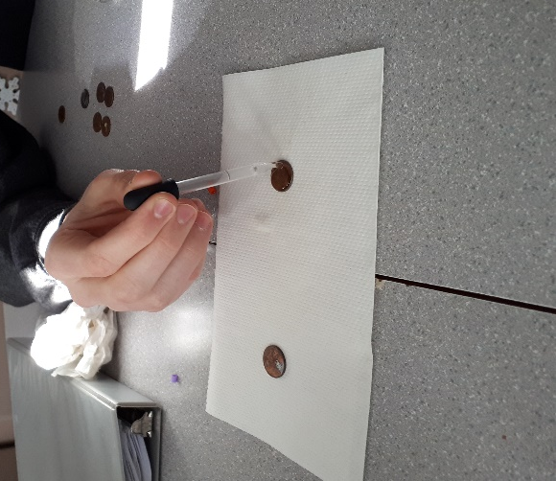 | Part Two: Labelled Diagram of observations:  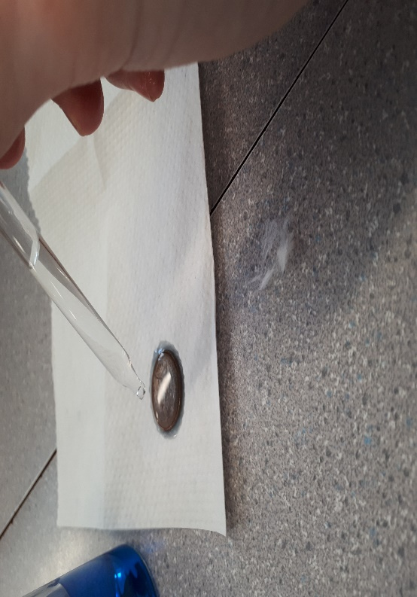
Description: In this portion of the the expiriment the drops of water are being place on the penny one by one. This is the penny without soap around it | Description: in the portion of the lab the water is being dropped on the penny which has detirgent on it. It is very prominent that the water is reacting differently than the penny without ditirgent as it is not rising due to the reduced surface tention
Results:
Group # | Average Number of water Drops on the Control Penny | Average Number of Drops on the  Penny submersed in the soap solution
Group One | 23 | 9
Group Two | 20 | 10
Group Three | 26 | 12
Group Four | 22 | 5
Group Five | 37 | 13
Group Six | 14 | 11
Class Average: | 24 | 9

Conclusion:
This experiment investigated…. How many drops of water can fit on one side of a penny

In order to study the problem … 8 different pennies were tested 4 of which were dry and 4 were dipped in detergent

Results showed… the dry pennies held a significantly higher amount of water that the pennies that were dipped in detergent

This proved the hypothesis that if… then…was (supported/negated) because…
- The hypothesis that was formed prior to the experiment was supported because the detergent weakened the bonds between the water molecules

To extend this experiment (explain what could be done) …
Finally, if the experiment was repeated, some changes to improve the experimental design could be...
- Some changes that would positively affect the results of experiment would be to use all the same types of pennies as some of them were American pennies and some were Canadian. Also, some were in much worse condition that others.

