Math 9 Finance Project PT II
You now have your net income, rent, phone and food costs. You are going to create a budget based around these costs and other living expenses. Here are the conditions for the rest of the expenses.
Car
Using https://vancouver.craigslist.ca/search/cta, find a used car to purchase. Provide a screenclip of the car, its price and accessories. For example…
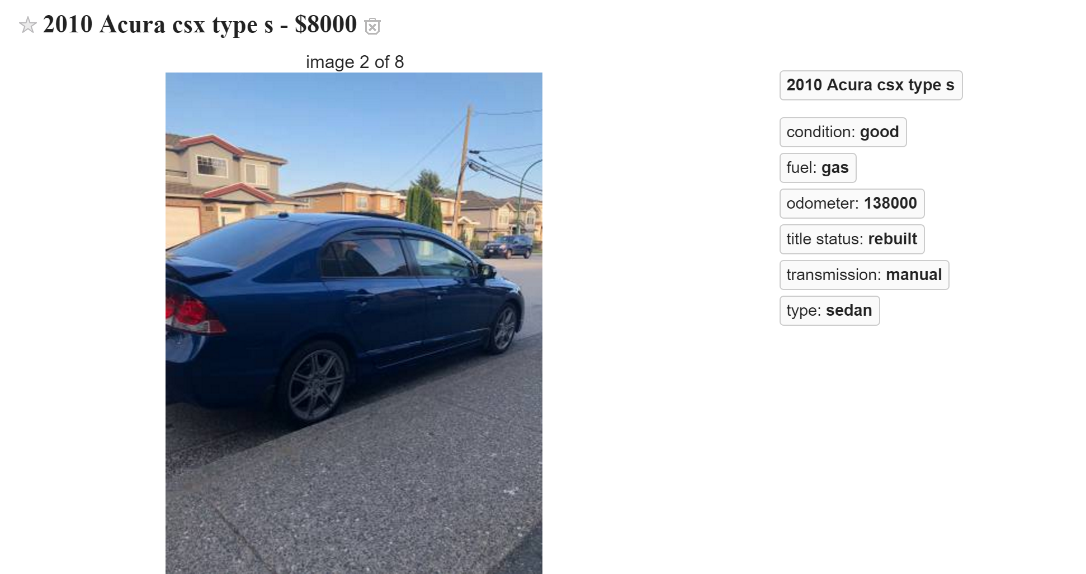
Go to https://www.caa.ca/carcosts/ and fill in the information you know based on the ad. Assume Annual Mileage of 20000km. This site will help you determine the costs of owning a vehicle.
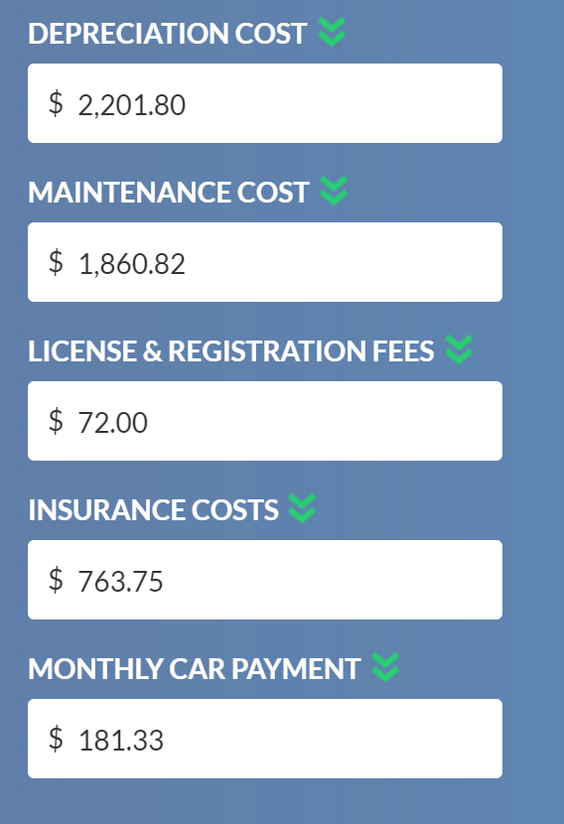
Take note of the Maintenance costs, insurance costs* and yearly gas costs.
Divide all those values to determine the monthly cost of the vehicle.
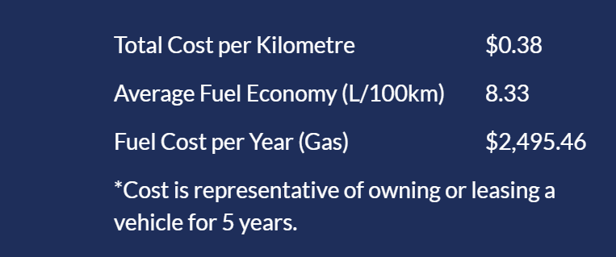
*note that insurance for a new driver is typically 2 or 3 times the cost of what’s listed here.
Add all this information to the first word document you were given.

With the given excel budget spreadsheet, you are going to fill in the costs for your NEEDS. These are costs that MUST be included in your budget:
Housing
Utilities: If utilities are included in your rent price, keep it at $0. If not, Assume $50 per month.
Car
- Maintenance
- Gas
-Insurance
Food: based on your family’s budget (note that this does not include restaurants)
Debt: Assume you have some debt to pay off. Your debt repayment cost will be 7% of your NET income
Internet
With the money left over, figure out what you can afford for restaurants, entertainment and any other WANTS that are important to you. Put these costs in the excel spreadsheets.
You cannot have a negative monthly cash flow. You may need to readjust expectations in order to live within your means.
Take a screenclip of your budget and include in the first document you were given.

Answer the following questions in the first document you were given.
- Which expense surprised you the most? Explain why or how they surprised you.
- Did you have to reduce or remove certain wants based on your income?
- What is the most important thing you learned with this assignment?
- Name one challenge you had with this assignment.

