**Section 4.4**

**Polygons** are **similar** if **both** of the following conditions hold true:

* Defn: A **Polygon** is a two-dimensional closed figure made of three or more line segments.
* Corresponding angles are equal
* Corresponding side lengths are proportional

<http://www.mathopenref.com/similarpolygons.html>

**Example 3:** Decide if each pair of polygons is similar. Show your reasoning.

**a)** CDEF and RSTU are parallelograms and

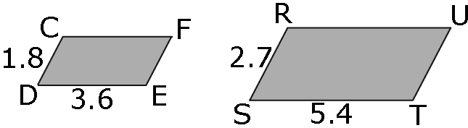

**b)**

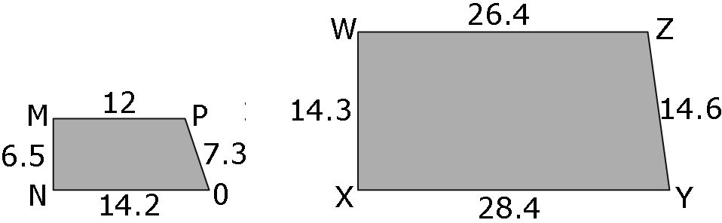

**c)** 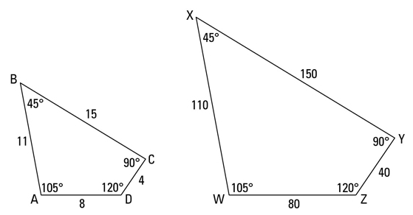

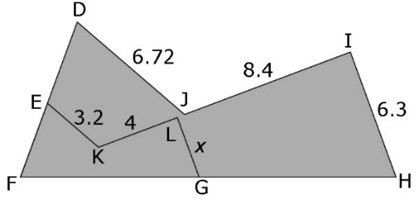**Example 12:**  The two pentagons DFHIJ and EFGLK are similar. Determine the missing length, *x*. Show your work.

**Example 13:** The trapezoid is a scale drawing of a cattle pasture. The actual length of the shortest side of the pasture is 200 m.

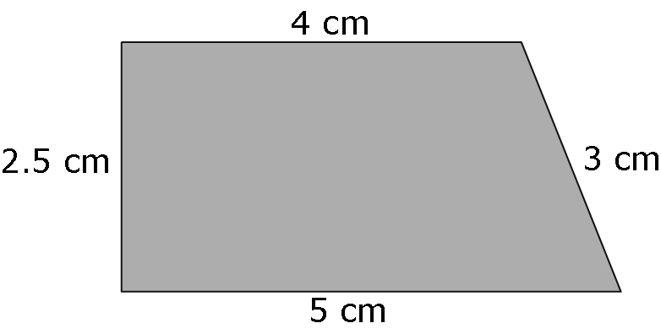

**a)** Use what you have learned about similar polygons to determine theactuallength of the other sides of the pasture. Show your work.

**Hint:** 200 m = 20 000 cm

**b)** How long is the fence surrounding the pasture? Show your work.

**Ex 14:** The image of Square ABCD is drawn using a scale of 2:1 if a side length of Square ABCD is 3.5 mm find the length of the diagonal . Round your answer to the nearest tenth.