11.1 Factors Affecting Data Collection
Prescribed Learning Outcomes (PLO’S):
  - Analyze a given set of data (and/or its representation) and identify potential problems related to bias, use of language, ethics, cost, time, timing, privacy or cultural sensitivity.

Big Idea: analyzing the validity, reliability and representation of data enables us to compare and interpret information.

Terminology

Surveys are used to collect opinions and information. Please fill out my survey using this link:
https://tinyurl.com/kz3xb29

Who might want to collect survey information? Think of surveys you have participated in, in the past. What kinds of questions were asked? How were responses collected? How might companies/organizations use this information?

Influencing Factors affect how data are collected or how responses are obtained, they include:

Bias – does the question show preference for a specific product?

Use of Language – Is the question presented in such a way that people understand what is being
asked?

Ethics – Does the question refer to inappropriate behaviour? Ethics involves judgement of
right or wrong. For example, cheating on a test is considered wrong.

Cost – Does the cost of the study outweigh the benefits?

Time and Timing - Does the time the data was collected influence the results? Is the timing of the
survey appropriate?

Privacy - Do people have the right to refuse to answer? Are the responses kept confidential?

Cultural Sensitivity - Might the question offend people from different cultural groups?

Consider the survey you completed, does it contain any influencing factors?

Activity: In your groups, look at the data samples, find an example of each of the influencing factors and be prepared to share your findings with the class.

SAMPLE 1 From Math Links 9 p. 417
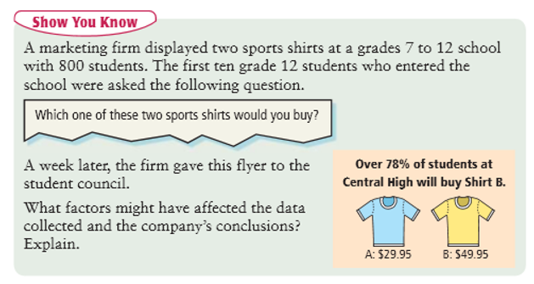

SAMPLE 2
The following question was asked of Canadians on an online poll in 2010.

Are you in favour of extinguishing the HST (Harmonized Sales Tax) and reinstating the PST (Provincial Sales Tax) in conjunction with the GST (Goods and Services Tax)?

SAMPLE 3
From 1919 Quebec prohibition referendum (look for the question)
https://en.wikipedia.org/wiki/Quebec_prohibition_referendum,_1919

SAMPLE 4
From 2004 Nova Scotia shopping referendum
https://en.wikipedia.org/wiki/Nova_Scotia_Sunday_shopping_referendum,_2004

Individual Task:

Create a new Edublog Post. Title it ‘11.1 Factors Influencing Data Collection.’ Categorize Math 9.
Choose one of the questions below. Describe the type of influence factor that might effect data collection. Reword the question to eliminate the influence factor.

Should concerned dog owners vaccinate their pets?

Should Christmas break be called winter break to avoid hurting the feelings of people who are different?

How irresponsible is Prime Minister Trudeau when it comes to backing the Kinder Morgan pipeline?

When purchasing a new laptop, do you look for one with more RAM and GB?

Independent Practice Math Links 9 Text p. 418 # 4-6, 8, 11

