Review Day 3 – Inequalities and Systems of Equations

A system of linear equations: 2 or more linear equations  
The solution to a system of linear equations is found by graphing the two lines, then finding the point of intersection.

1. Solve the system

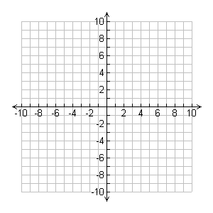





1. Solve the system



Inequality review:

1. True or False
   1. 3 > 5 b. 3 > -5 c. -3 < -5
2. Does the point (1, -2) satisfy the inequalities?   
     
     

1. Solve the inequalities algebraically
   1.  b.  c. 