Review Day 2 – Slope and graphing







1. Find the slope passing through points A(2, 5) and B(-3, 6)
2. Graph a line with:
   1. 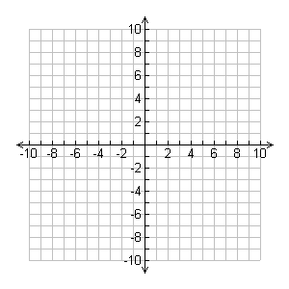Slope 2 and point A(1, 4)
   2. Slope  and point B(-2, 0)
3. Graph the equation of a line
   1. 



* 1. 

1. Find the equation of the line passing through A(-2, 0) and B(-1, 5)