7.3 Solving Quadratic Equations by Graphing

Complete the following:

*Y-intercept means ____________ and that is where the graph crosses the ________*

So,

*x-intercept must be when ________ and that is where the graph crosses the ________*

Sketch:

Example: Solve  and determine the zeros,

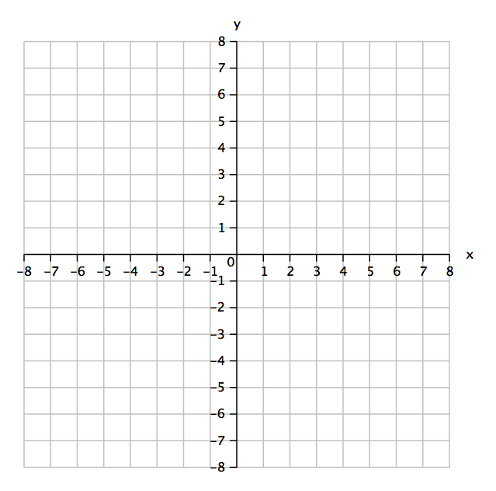

**Solve:**  by graphing and determine the zeros.

**Solve:** by graphing.