**7.6 - Vertex Form of a Quadratic Function**

Quadratic functions can be written in **general form** or **vertex form**.

General Form: y = ax² + bx + c Vertex Form: y = a (x – p)² + q

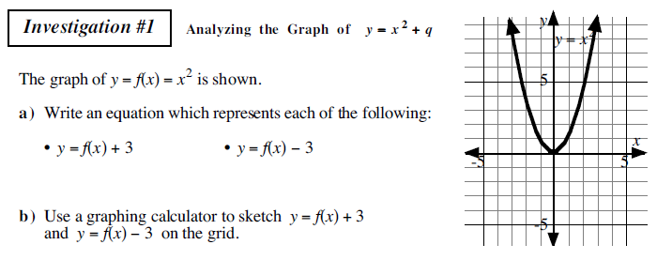



What do we know?

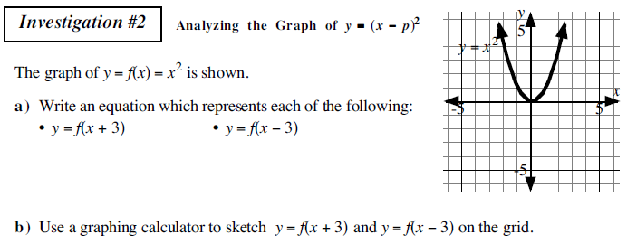



What did we learn?

Putting it all together. How would you explain Vertex Form to someone else?

Show me you understand:

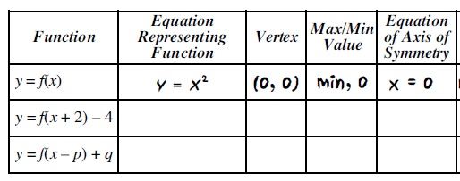



Time to show off:

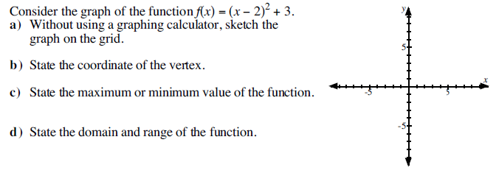

**Example**: Determine the quadratic function corresponding to this parabola.

