7.4 Factored form of the Quadratic Function

Quadratic Intercepts Factor

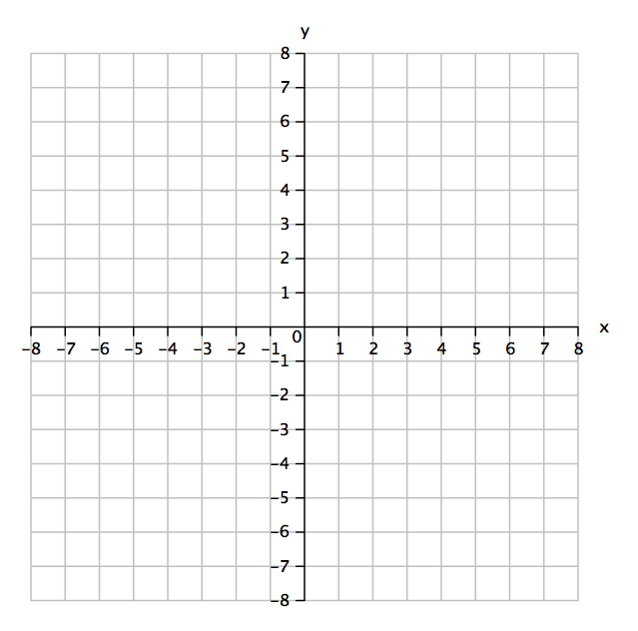Graph: 

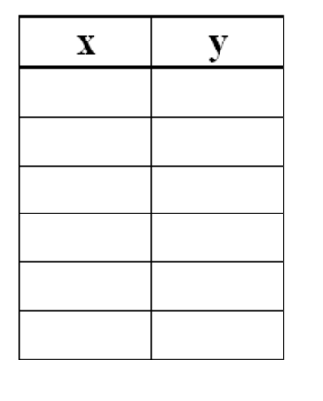

Minimum/maximum

Line of symmetry:

Vertex:

Domain:

Range:

What are the interesting points on this graph?

All quadratic functions can be written in factored form:



Example 1: Sketch the graph of 

What do you know about the parabola?



Factor the quadratic:

Find the x-intercepts (zeros). Look at each factor separately.

Line of symmetry:

Vertex

Example 2: Determine the quadratic function that defines this parabola. Write the function in standard form.

