Bearings and Word Problem Review
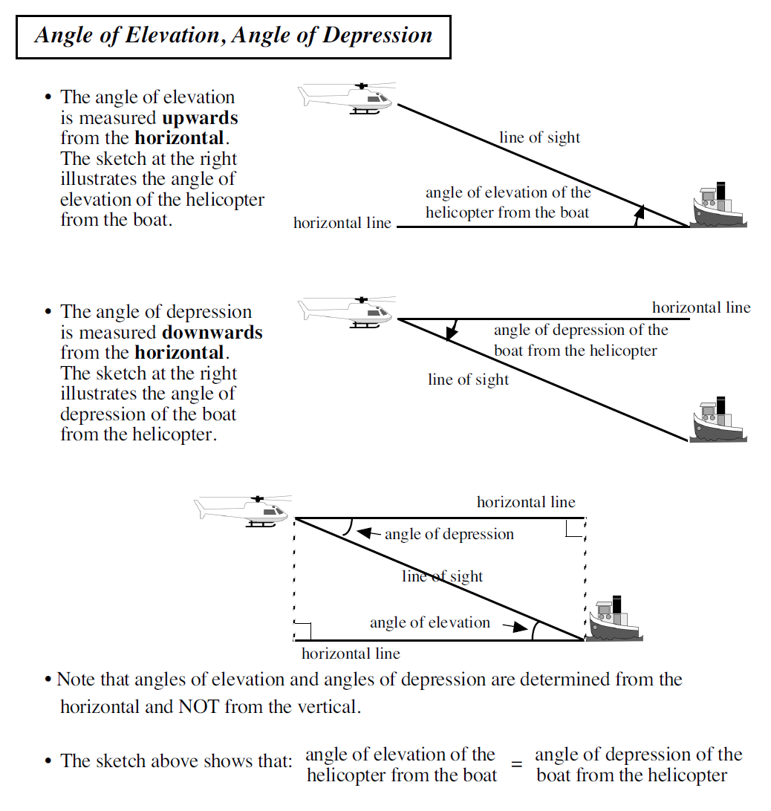

Example 1. A boat is 130 m from the base of a cliff. The cliff is 80 m high. Draw a diagram to represent this scenario and mark the angle of depression from the top of the cliff. Determine the angle of depression.

