6.3 Graphing to Solve systems of Linear Inequalities
Example 1. A company makes two types of boats on different assembly lines: aluminum fishing boats and fiberglass bow riders.
- When both assembly lines are running, a maximum of 20 boats can be made in a day.
- The demand for fiberglass boats is greater than the demand for aluminum boats, so the company makes at least 5 more fiberglass boats than aluminum boats each day.
What combination of boats should the company make each day?
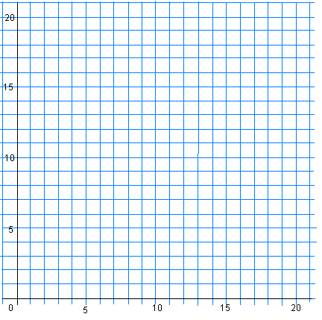

Example 2. The staff in a cafeteria are making two kinds of sandwiches: egg salad and ham and cheese.
- A maximum of 450 sandwiches are needed.
- Based on previous demand there should be at least twice as many ham and cheese sandwiches as egg salad sandwiches.
- Define the variables and write a system of inequalities
- Use desmos to find a possible solution

