7.2 – Analyzing Quadratic Functions

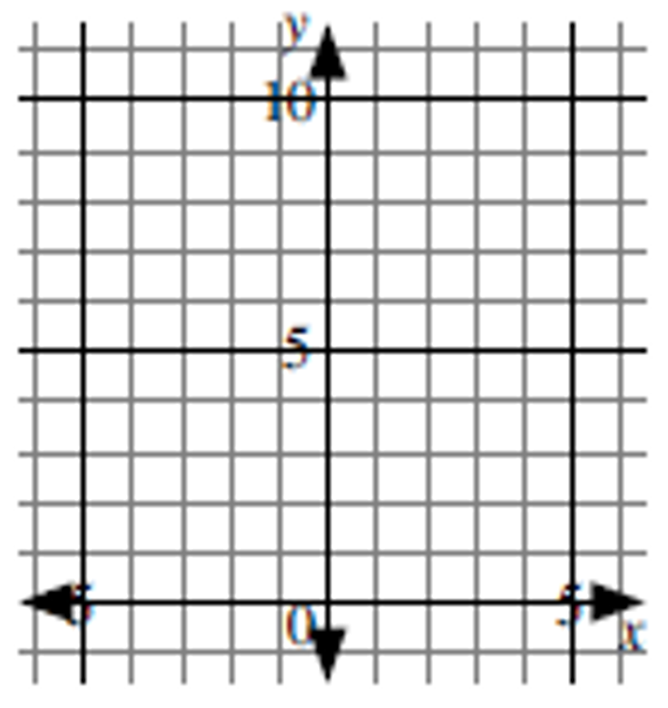

Graph the function with equation  by completing the table of values.  
Join the points with a smooth curve. The graph of this function is called a  
parabola.

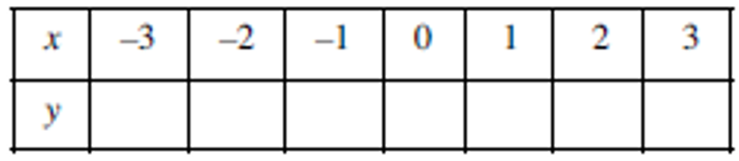

The **axis of symmetry** is the “mirror” line which splits the parabola in half.   
State the equation of the axis of symmetry

The **vertex** of a parabola is where the axis of symmetry intersects the parabola. The vertex can represent a minimum point or maximum point depending on whether the parabola opens up or down.   
  
Label the vertex V on the graph and state its coordinates.   
  
The maximum or minimum **value** of a quadratic function occurs at the vertex and is represented by the y-coordinate of the vertex. Complete the following:

The ______________ value of the function with equation  is ____.

State the domain and range of the function with equation , .  
  
Domain: ______________________ Range: _________________________ 

