8.1 – Interpreting and Comparing Unit Rates
Review:
30 km in 20 minutes Convert 2.3 L =_______ mL

Is it better to receive $440 a week or to be paid hourly at a rate of $11 per hour? What factors could affect your decision?

Example 1: You can buy a 12 kg tofu roast from the butcher for $42.89 or the supermarket for $1.49/lb. Which as the lower price?

Example 2: Orange juice is sold in 1.5 L cartons and 250 mL boxes. A 1.5 L carton sells for $3.75 and ten 250 mL boxes sell for $7.39. Which option is a better deal? (Which size costs LESS per millilitre?)

Example 3.
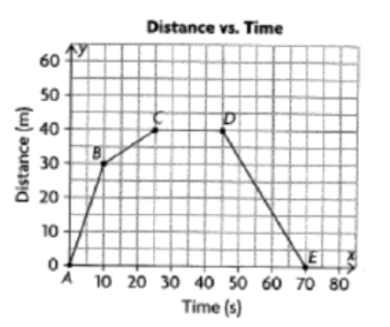
What is the speed in the section A-B? In the last 20 seconds?

What happened from C to D?

How long was the trip?

What do you remember about slope?

