**6.1 - Graphing Linear Inequalities in Two Variables**

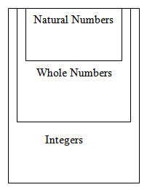

A mathematical inequality must contain one of the following: > > < < 

Examples of linear inequalities in a **single** variable: 

The **solution** to a single variable inequality can be shown on a number line:

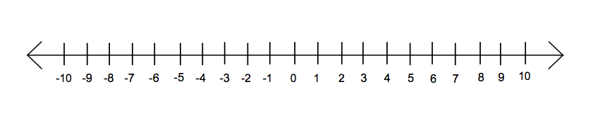

Solutions for a **double variable inequality** can be shown on a Cartesian plane.

**Example:** Graph the solution set for

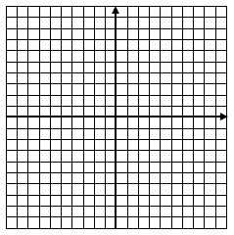

**Example 2:** Graph the solution set for each linear inequality on a Cartesian plane.



$\{\left(x, y\right)| x-2 >0, x ∈R, y ∈R\}$

1. 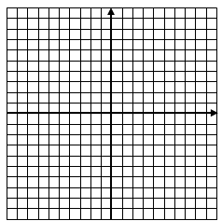{(x,y)| -3y + 6 $≥$-6, x $∈I, y ∈I\}$