Acute Angle Trigonometry

From Math 10…

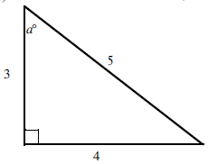Label the sides opposite, adjacent and hypotenuse for angle *a*o.

Primary trigonometric ratios:

sin(*a*o) =

cos(*a*o) =

tan(*a*o) =

Example 1. From the equation, state what you know about the triangle, what part of the triangle is unknown and solve.

1.  b)  c) 

Example 2. Determine the value of each ratio. Round to four decimal places.

1.  b)  c) 

Example 3. Determine the measure of each acute angle, to the nearest degree.

a)  b)  c) 

Example 4. Solve triangle ABC (determine all unknown sides)



Example 5. Which is the longest side in each triangle. Which is the shortest? Explain how you know.



Example 6. Which is the largest angle in each triangle? Which is the smallest? Explain how you know.

