5.5 Normal Distributions and Z scores

**Warm up:** Draw a normal curve with a  and  = 5

1. What % of data is between 20 and 25?
2. What percent of the data is between 20 and 22.5?

When we want to talk about a particular piece of data within a set, describing **how it relates to the average is referring to its z score.** We can also compare scores from different bunches of data. The z score tells us how “typical” a score is within a set. It also helps us find percent of data between standard deviations and the probability of a score occurring.

If a z-score:

= 0 it means __________________________________________

= positive it means __________________________________________

= negative it means __________________________________________

= +1 it means __________________________________________

=-1 it means __________________________________________



**Example**: if  ,  and 

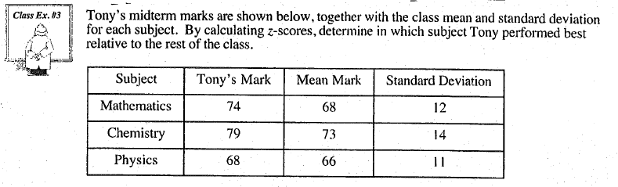

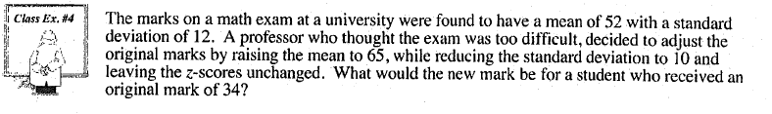

Example:

