The Fable of Banquo
Intelligent “If the witches tell the truth—which they did about you—maybe what they said about me will come true too” (act 3, scene 1, pg 1) observant is the young Banquo and hopeful is he, that he too will have a royal blood line eventually
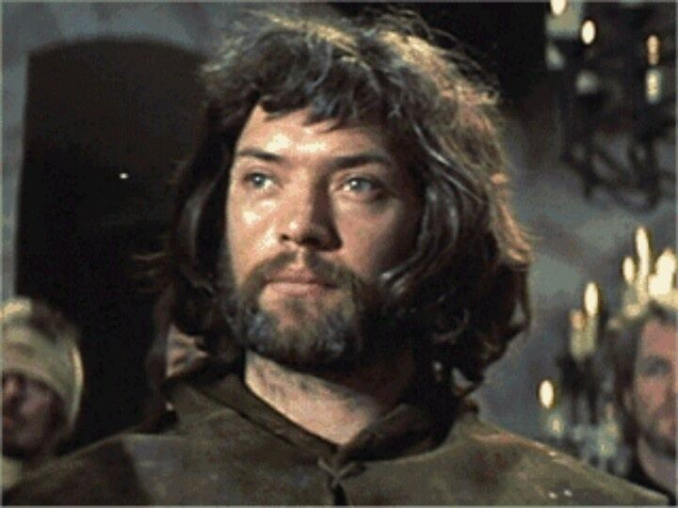
Brave “Get out of here, good Fleance, run, run, run!” (act 3, scene 3, pg 2) shouting at his son when the cowards attacked them, murdered was he
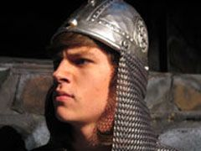
Loyal “I’ll do whatever you say, as long as I can do it with a clear conscience.” (Act 2, scene 1, pg 2) loyal as can be, he followed macbeth till his dying moment, admirable, anyone could see
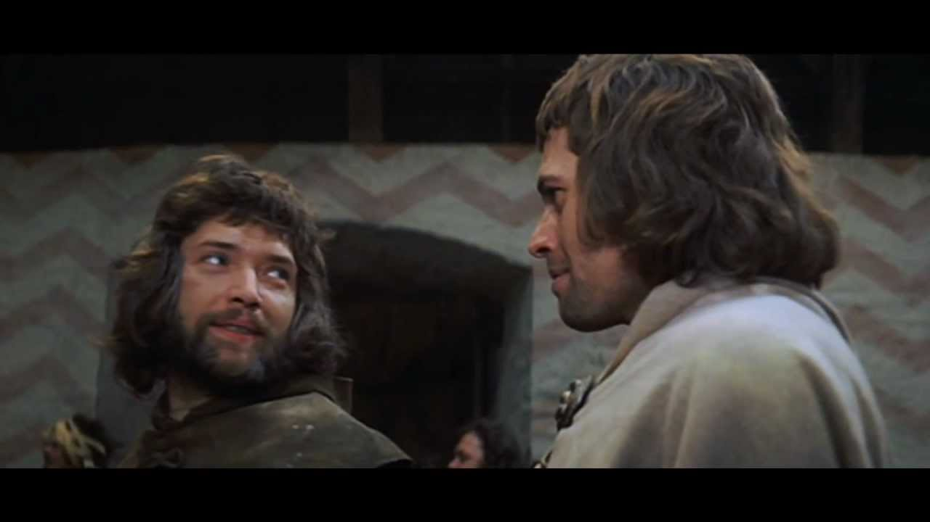
Courteous “Then if I accomplish anything great, it will be a credit to you” (act 1, scene 4, pg 2) talking to Macbeth as a true brother, a general couldn’t ask for more. a loyal bond and beyond that is the key
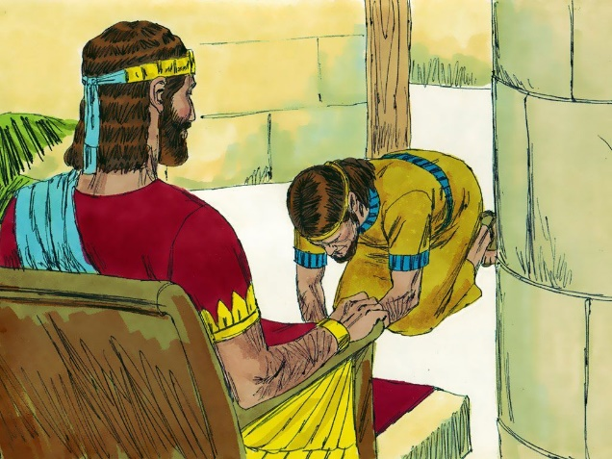
Observant “The fact that this summer bird, the house martin, builds his nests here proves how inviting the breezes are” (act 1, scene 6, pg 1) a bird watcher he might be but savvy with bird facts even though they aren’t nested in a tree.
