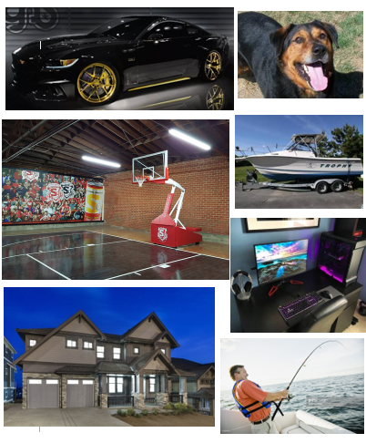

2.
A. When I am 25-30, I will live a very relaxing lifestyle. I will work not very often and will be spending most of my time playing basketball, fishing, and gaming.
B. A typical day would be having a short shift as a dentist in the morning, then going home and playing some PC games, and then maybe spending the afternoon shooting a basketball around with some friends
C. Overall, I want to live a life between a regular and luxury life. I want to do the things I love and live a happy lifestyle.

3. If I live in an area where there are not many dentist, I could be making an upwards of $200k

4.
A. Cost of 2016 GT Mustang = $40 000
B. Cost of dog = 500, Cost per year to own German Shepherd = $1200-$1500
C. Cost to own a basketball hoop = 1.5K
D. Cost of boat = $20 000
E. Cost of gaming setup = $3000
F. Cost of my house in Coquitlam = 2 Million Dollar
G. Cost per each fishing trip (gas, bait, etc.) = $150

